A Voyage of Healing

Invited Lecture, by Robert Miller
given on 4th November, 2017, at the Hong Kong Mental Health Conference (3rd-5th November, 2017)

Part I
Introduction:
I want to start by thanking the Conference Organizers, and particularly Eric Chen for giving me the opportunity to speak today. Giving this lecture is an important stage in a long voyage for me. ‘Mind, UK’ has likewise been on a long voyage over the same period. However, the theme of my talk is that there is now a need for a new beginning, or at least a need to dig deeper foundations; and in Hong Kong, this fascinating place where East and West are so richly blended, perhaps this is possible.
My talk has turned out to be in two parts. I have called it ‘A Voyage of Healing’; and I refer to healing on several fronts. The word ‘heal’ has the same origin as the words ‘health’, ‘whole’, ‘holy’ and ‘holistic’ - the bringing together of disparate parts, so they function together in an organic unity. That is very much my concept of mental health: The human brain, and the mind it embodies, are designed - if I can use that word - to construct for each of us a sense of being a coherent, unified entity, in other words ‘a person’. None of us ever attains a state of perfect wholeness, but the journey we all travel has the goal of achieving this as closely as possible. This is what Victor Frankl referred to, when he entitled his short book: ‘Man’s Search for Meaning’. That is our voyage.
It is appropriate to speak on this theme here in Hong Kong, under the aegis of Mind UK, and Mind, Hong Kong. As I understand it, Mind, UK grew from initiatives of the mental hygiene movement, early last century started by Clifford Beers in the USA, and his book – ‘The Mind that Found Itself’; and when Mind, UK itself was established soon after the second World War, its agenda was the sort of holism to which I have referred. As a young man, I suffered a serious mental disorder, which received the diagnosis of schizophrenia - a term which, in Eugen Bleuler’s definition, meant a fragmentation of the normal unity of psychic functions. So part of my voyage, has been to regain a sense of wholeness, as full a sense of personhood as possible. However, I use the term ‘healing’ to refer also to the repairing of fragmented social relationships in the various disciplines involved in mental health care, some of whom do not seem to grasp the idea of holism. Fragmentation has come through force of historical circumstances, rather than deliberate ill-will; but my perception is that now, in many countries, mental health care is split amongst many players, who should collaborate, but sometimes spend more energy trying to preserve their own power base. Perhaps, at age 74, I am in a strong enough position, and with detached enough viewpoint, to suggest ways to mend some of those rifts.

Some of My Own Story.
Let me tell you a bit of my own story: I was born in the British industrial city of Sheffield, in south Yorkshire in 1943, and did my schooling there. At secondary school, I went into the science stream. In my last year there, in the school library, I came across a book by J Z Young, then Professor of Anatomy at University College London, one of the most outstanding British biologists of that era, called ‘Doubt and Certainty in Science’ - the published version of his 1950 Reith lecture series. At age 17, I was introduced to the amazing idea that all the subjective impressions which flit through our minds, moment by moment, are the product of mechanisms in our brains, which might be comprehensible. I was hooked - no other word will do - and I’ve been thinking about that ever since. I was intrigued more by philosophical questions, the focus of J Z Young’s book, than the experimental side of brain research.
I got to Oxford the following year, to read medicine. There, I spent a great deal of time learning about the brain - and I should say - right from my first year, reading original research papers - which does not happen now in many universities. I did not do so well in the exams! However, other things were happening. Even at secondary school I was a moody individual, and at Oxford, I experienced a remarkable succession of mood swings, which impaired me considerably. I consulted a general practitioner, then a psychiatrist, who prescribed tricyclic antidepressant drugs. These caused serious autonomic side effects, certainly changed the state of my mind, but were a poor short-term solution to my problems, and hopeless as a long-term one. The darkest period was six months in 1966, when I was a clinical student at University College Hospital, in London, still struggling with fluctuating moods, impaired in my studies, yet trying to become a physician. I was prescribed tricyclics again, went home to Sheffield while they took effect; and then quite suddenly, one morning, I became floridly psychotic, and was admitted to the mental hospital in Sheffield. The psychiatrist who committed me was one Erwin Stengel, from Vienna, one of those distinguished refugee psychiatrists who did so much to reform psychiatry in post-war Britain.
There is much detail that I could relate, but I will skip most of it. The attempt to get a medical degree was abandoned. For three years I was convinced there was no future for me at all, a long time at age 23; but in 1969 I landed a job as a research assistant in the University of Glasgow, in Scotland. That was the beginning of my voyage of healing. I did get a doctorate there, on a neuroscience topic, not a great piece of scientific work, but an important staging post. After that, I was back in Oxford in a post-doctoral position.
In autumn 1973, several important things happened in quick succession: First, I had another brief period in hospital – a good hospital, the Warneford in Oxford – as a result of stopping my medication. I have interesting comments to make on that later. Second, at an outpatient appointment, I discovered what the diagnosis was - saw it written in my case notes. How I learned that – another fascinating story – but for another time. Third, on getting out of hospital, I realised that, whatever health problems I had, were manageable. So, it was a time for big decisions. I had a detailed memory of my periods of illness, had learned much about psychotic illness, and how antipsychotic drugs work subjectively. I had as good an education in the neurosciences of the time as one could get. I realised that clinicians who tried to help me, despite their undoubted clinical skills, had little scientific understanding of the disorders they dealt with. In fact, at the last session I had with the psychiatrist in Sheffield – not Stengel actually - he actually admitted that; and I take that as a mark of his integrity. So, I conceived the idea that, if possible, I should devote myself as a scientist to trying to understand those disorders. Of course people told me - and still tell me - that this was impossible. Well, those guys had not met many Yorkshiremen. Tell a Yorkshireman that something is impossible, and he’ll take it as a challenge; and you’ve probably got a fight on your hands!
Neuroscience Research: Axonal Conduction Time. What else? On the scientific front, two developments: I started to read about that messenger substance dopamine, and that was the lead into my understanding of psychotic episodes such as I had experienced. But let me say a little about the experiments I was doing as a post-doc student at Oxford. They were animal experiments, on anaesthetised cats. It will upset some people to hear that, for which I apologise; but I should be honest with you. I would be happy to give my views on animal experimentation, which might surprise you. The simple facts that I discovered were about properties of nerve cells in the cerebral cortex, in particular, their nerve fibres – their axons. For the connections between one part of the cortex and another:- How long – how many milliseconds - did it take for a nervous signal to make the journey along an axon? In a population of nerve fibres, what was the range of conduction times? Within such a population, I found that there were considerable differences between different axons. So between any two points in the cortex we can talk about a ‘repertoire of delay lines’. Simple facts, but not many people know them even today, forty years later; and they were the corner-stone of the work I did subsequently as a theoretician. When I did the experiments, I had no idea where they would lead.
Emigration to New Zealand: Comments on My Transition at This Stage. I had further periods of post-doc study, but it became clear that, in Britain at the time, I would never get a secure academic position; and in 1976, I was offered a job in the Anatomy Department, far away in the University of Otago, New Zealand. I emigrated there at Easter 1977. On arrival, I began slowly to gain confidence, and discovered the sort of research I should be doing. I am no good at experimental research; but I love reading hundreds of research papers, and working out the larger patterns, to make sense of brain processes. So, gradually I was transformed into what I now call myself - a library-based theoretician of the brain.
There are a few observation I want to make on this transition: In my struggles to find a way forward, before emigrating, I met quite a quite number of eminent psychiatrists and researchers, some relatively benevolent, others who seemed to be quite ferocious – I give no names of course. I was in a very vulnerable state with regard to career prospects, but I turned my back on them all. Why? Some deep inner intuition told me that I wanted to go in a direction quite different from what they had to offer. In addition, they had that air of unchallengeable authority, which I could never accept. On reflection, many years later, I can be more specific. Psychiatry at the time was steeped in authoritarian attitudes, based on styles of administration of asylums; in addition, most of the people I met had had, as their formative experiences, various roles in the armed forces during the war, either as junior physicians or psychiatrists, or in other ways. Combine the two, and perhaps you can see that there was an impenetrable barrier to open discussion, or helping me, in my difficult situation, to find my true identity. There are two exceptions, persons who I want to mention by name:-
The first is Peter Usherwood, my doctoral supervisor at Glasgow, seen there with his wife Gloria, who, sadly, died last year.

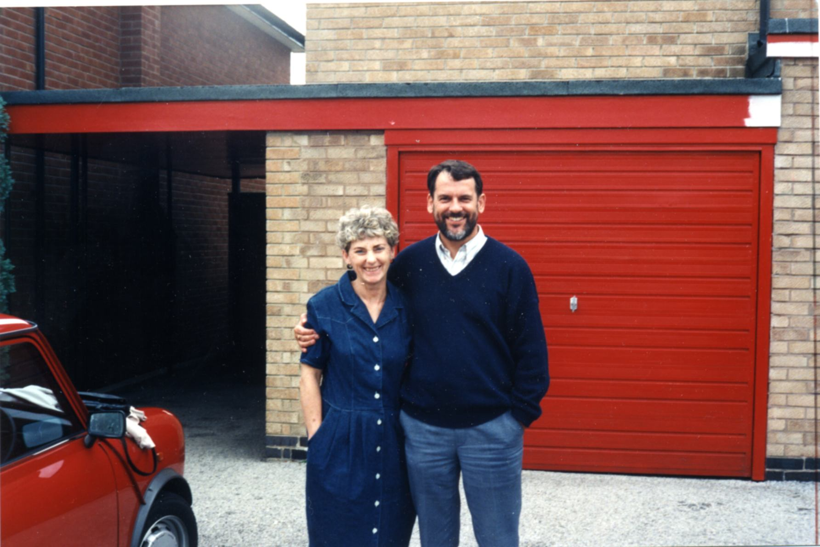

The other is Charles Phillips, Professor of Neurophysiology, at Oxford, who was a great support at the time of my admission to the Warneford, and when I applied for the job in New Zealand.
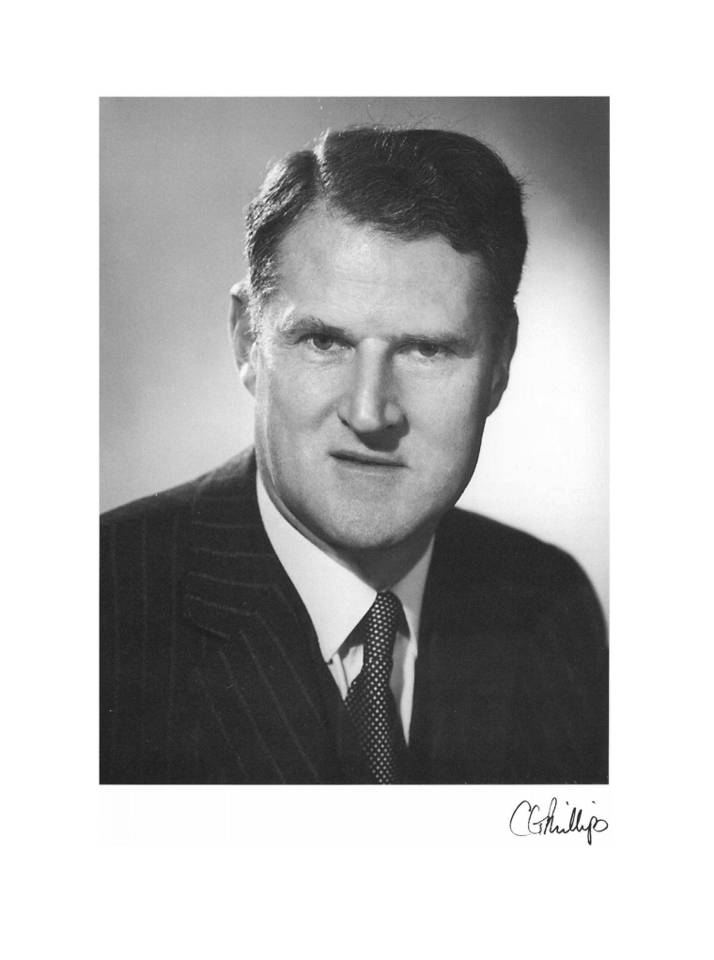
I sum all this up now, with my belief that the most fundamental of all ethical principles, generally absent in those days in all walks of life, is transparency and openness.
Origins of Ethical Sensitivity:
Let me add a bit more about how my ethical sensitivities developed. I suggest that such sensitivity is not to be taught: It is learned by example from people you trust, and by life experience. In major part, I owe this to my father. He was a physicist, but when World War II came, he took a conscientious decision that he was not going to use his expertise in war-related research, and so he became a medical physicist. This was a very important profession during the Cold War, because many of its members had similar backgrounds, combining technical expertise with deep ethical commitment. Perhaps I try to achieve the same combination as a neuroscientist. I will refer to that profession again in the second part of this talk. A couple of other personal reminiscences: At age 17, as a member of a film society in Sheffield, I saw a documentary film called ‘Nuit et Brouillard’ – a French title, translated as ‘Night and Fog’ – the footage that a French film crew took when Dachau concentration camp, near Munich, was liberated at the end of World War II. Horrific, yes! Piles of corpses everywhere, as if they were piles of industrial waste, which in a sense they were. This film was not available on public release. My reaction? Very little, at the time. In post-war Britain most aspects of life made little sense; anything was possible. But then, fifteen years later, around 1974, I was back at Oxford, and, after two periods in hospital, I went to a seminar on Autism. I heard the speaker address the audience saying that she thought the stresses that autism puts on families was so great that persons with that diagnosis should be prevented from ever growing up. Basically she was advocating euthanasia. I was a very fragile person at the time of course. My reaction? I walked out in tears.

***********************************************************

So that is the story up to the time I arrived in New Zealand. It may have set some of you thinking. If not, can I ask you a challenging question? I’ve described various formative experiences, a first rate education in the neurosciences of the day; first hand experience of a serious mental disorder; and other experiences which forced on me a keen sense of medical and research ethics. The question I ask you is: If you had been dealt that hand of cards, how would you, have played that hand?
Possible topics for this lecture: When I was invited to speak at this conference, I had all sorts of things I wanted to include, things which I have never had an opportunity to express in public, accumulated over many years: My growing scientific understanding of mental disorders; my ideas about antipsychotic drugs; what I think about the term ‘schizophrenia’; why I have now abandoned using the term; recent readings in the history of psychiatry, including work at present in progress on how psychiatry as a discipline has been distorted by two World Wars and the Cold War; and a wide range of professional issues for psychiatry and other mental health care professions. This is too much for one lecture. Moreover, when I sent a draft of what I might say to Eric Chen, he said that the overall impression was a bit too negative. This was true; and not at all my intention.
The professional issues are important, but details differ greatly from country to country. You are an international audience, so I will say only a little on that. However, I point out that I have never worked in the mental health professions, absorbing their ways of thinking, but have been on their fringes for many years, taking in impressions and digesting them according to my own ways of thinking. So, of course, what I come up with may be unfamiliar to you, sometimes in fundamental ways. Inevitably, if I am to be true to myself, what I want to say may be challenging for you. Nonetheless, I hope it will be positive in tone. I want to place emphasis on topics where I can make my most distinctive contribution and apply which-ever country you come from. These are at the interface between the science I know about, and the practice of psychiatry and related disciplines. The focus will be on our concepts of human nature. This connects to all the other topics, and is significant in two specific ways:

Relevance of Concepts of Human Nature.
It should be around our concept of human nature that we build our ideas of mental disorder; and our notions of human nature are also crucial in designing those complex social systems by which health care, including mental health care is delivered. In addressing this questions, I speak first as a neuro-scientist. By the end of the second part of this lecture, I hope to portray myself as a more rounded person.

Significance of Experiments on Conduction Time in Axons.
With regard to experiments I did as a post-doc, the findings led me by 1991 to a theory about how the mammalian brain (including the human brain) discovers the most useful contexts which make possible higher mental functions. The word ‘context’ is important here, and I refer to it later. The book I wrote on this was called ‘Cortico-hippocampal interplay, and the representation of contexts in the brain.’
By 1995 I was led to a theory based in part on my understanding of the properties of nerve cells, to explain why left and right hemispheres of the brain have different functional abilities. My book on this was called: ‘Axonal conduction time and human cerebral laterality’.
Then, by 2008, I used similar reasoning to give an explanation of what I refer to as the ‘non-psychotic traits’ associated with the disorder called schizophrenia. My book on the whole theory of this disorder was called: ‘A neurodynamic theory of schizophrenia and related disorders’.
Quite recently, and not yet fully formulated or written up, those experiments in the 1970s have continued to bear fruit, in that they have contributed to my formulating an account of how our brain constructs for us a sense of being an integrated person – a theme I will focus on shortly.

History of the Natural Sciences
But, now for a moment, let us step back from mental health and psychiatry. What we now call ‘science’ or the ‘natural science tradition’ started about 400 years ago. The first person to write about science as a method, was not himself a scientist, but a philosopher and statesman, contemporary of William Shakespeare, Francis Bacon. I often find myself quoting his major work from 1620 - Novum Organum – ‘the New Method’. The following line is very relevant today:

‘If the notions themselves are confused, and over-hastily abstracted from the facts, there can be no firmness in the supra-structure.’
Core Concepts in Physical Sciences; and for Mental Health
Probably, Bacon was referring to the confusion of concepts for the physical sciences -Natural Philosophy, as it was then called. Today, there is similar confusion in our area, about fundamental notions for mental health, and psychiatry.

Core concepts in physical science:
Length
Time
Mass Force

Core concepts for mental health:
Human nature
Discovery of meaning
Context Meaning

In natural philosophy, there were four key concepts, definition of which made science possible – length, time, mass and force. Definitions of mass and force were not obvious until 60 years after Bacon died, but Isaac Newton gave each of them precise definitions, which were closely interrelated, in his scheme of natural philosophy. They depended on each other. For our area of concern, the central concept, still shrouded in confusion is human nature itself, in all its diversity - I’ve added a few more key concepts which I will explain later – and I do believe this can now be based on robust science.

Central Concept for All Mental Health Professions: Human Nature itself.

Three models of human nature
I can think of two earlier models of human nature. For the ancients, starting off in classical Greek culture, the idea was that the defining feature of human beings, which separates us from animals, is rationality – the faculty for reason. Well, some of us do sometimes have this ability to a limited degree; but if you say this is the defining characteristic of human beings, I scratch my head in puzzlement, given the contortions of some of our political leaders in recent months! As an alternative, growing in the twentieth century, many have tried to understand human nature in terms of classical physics, and all the technology to which it led. This is what I would like to call the ‘engineering model of human nature’. Now, don’t get me wrong: The application of principles from classical physics to biology and medicine has had huge impact on our understanding, and has led to many Nobel prizes; but generally these have been at the level of the component parts – for instance, in the nervous system, our understanding of transmission of electrical and chemical signals, neurochemistry and so forth. When it comes to understanding the human person, attempts to use similar paradigms of thinking have often been disastrous. To go beyond that, I make the rather enigmatic claim that the human forebrain is designed to discover meaning. In saying this, in no way am I suggesting that we abandon any basic principles of physical science. However, the way we use those principles must be utterly different when dealing with the immensely complex entities in the biological and social realm, compared with the simple ones, from which the natural science tradition grew. I come back to this towards the end of the second part of this lecture. But, by way of introduction, let’s delve further into history:
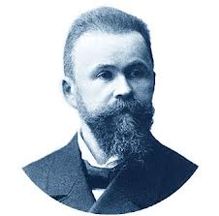

Carl Wernicke: A few years ago, I became involved, with a linguist and anatomist friend of mine in New Zealand, John Dennison, in translating from German - and editing - an important work from the 1890s, Carl Wernicke’s Grundriss der Psychiatrie in Klinische Vorlesung – ‘Outline of Psychiatry in Clinical Lectures’. In the English-speaking world, Wernicke is known as a pioneer of neurology, but that refers just to the early part of his career. The last twenty years of his life were spent working in a mental institution in the German city of Breslau, now Wroclaw in western Poland, which is where he gave these 41 lectures. Sadly, he died prematurely in 1905, at age 57 in a bicycling accident; his Grundriss der Psychiatrie was largely forgotten, even in the German-speaking world, eclipsed by writings of others, such as Emil Kraepelin.
For me, it was a huge privilege to be involved in producing the first accessible version of that work in English. Without hesitation, it is the best scientific writing about mental disorders I have ever read. Sure - he made some big mistakes; but basic knowledge we now have about the brain was not available to him. At his best, he was far ahead not only of his own time, but I suspect, of most of today’s mental health practitioners. Let me be clear here: When I say that, I’m not comparing his clinical skills with those of today’s practitioners. I’m sure there have been, and now are today many excellent psychiatrists with clinical skills to match his, or in advance of his. I am talking about scientific understanding, which is what I always look for; and I have read nothing to approach him. Other pioneers – Sigmund Freud, Carl Gustav Jung - tried to base concepts of mental disorder on broader concepts of human nature; but I have not found anyone else to ground his concept of human nature so successfully on the neuroscience of his day.

Wernicke’s model of personhood
He starts from the assumption, obviously close to the truth today, but very bold in his own time, that the cerebral cortex was the ‘organ of association’, and so could gradually accumulate myriad associations between all the sensory messages it receives each hour and each day. Broadly there were three types of association:- [a] those which give us awareness of our own body, through the sense of touch, and from prioprioceptors (giving us a sense of bodily movement) and interoceptors (which tell us about our internal organs); [b] awareness coming from the ‘distance senses’ – vision and hearing - of the outside world (including our social environment); [c] the unique sequence of episodes of life for each individual. By assimilating these three, Wernicke explains how our brain constructs for each of us our sense of ‘being a person’; and then continually reconstructs and updates that sense of being a person. That is the voyage upon which we are all embarked. I will take that idea forward to our own time in the second part of this lecture. So I finish this first part with the key quotation from Carl Wernicke, his Lecture number 7 (as translated by John Dennison, with a little help from myself):

‘To personalised consciousness belongs the sum of experiences peculiar to the individual. The individual we see before us always represents that sum total – a sum having a definite value only at a specific point in time, but which undergoes new growth every hour and every day. The current state of the brain is always this final summation of all previous states.’

This is where I will start in the second part of this lecture. Thank you.

PART II
Just to remind you, I ended the first part of this lecture with Carl Wernicke’s concept of how our brain allows us to construct the concept of ourselves as an enduring entity – that is as ‘a person’- and then continually reconstructs and updates our sense of being a person.

Modernised Version of Personhood, after Wernicke
So, how do we get to a more realistic model of what it is to be a person, based on modern brain science? Wernicke’s model provides a good start; but today, we can build on that to give a much-improved concept of personhood. The two concepts which I think are critical, are those of ‘context’ and ‘meaning’; and, just as definitions of mass and force are interdependent in Newton’s physics, so definitions of ‘context’ and ‘meaning’ depend on each other.
The ‘engineering model’ of human nature tends to assume that our brains are designed for ‘processing information’ – and information, as in all our computers, is quantified as a large number of ‘bits’ which are independent of each other, not connected by any broader framework for interpretation. As a way to understand human personhood, I suggest that this is incorrect. What our brains are designed for is to discover meaning. Meaning is not the same as information. Meaning is information which is located in a context; and for humans, that context may be a whole lifetime of experience. Meaning then is a concept to apply to living organisms; information is a central concept for technology, part of an engineer’s vocabulary. Computers, as processors of information, have never yet been designed in such a way that they can work out the best contexts for use on each occasion, as can our brains.
How do we relate this to the brain? How do we relate it to the realities of our troubled existence and our complex life stories? I start from Wernicke’s assumption, that the cerebral cortex is the ‘organ of association’; but this is an incomplete formulation: Associations might spread too freely, to become ‘over-inclusive’ with a tendency for nerve cells to be activated by quite tenuous links; and then a person’s style of thinking may appear ‘gullible’ to an outsider, accepting too readily that chance coincidences reflect reality. So, a mechanism is needed to limit these associations to a small fraction of what is possible in terms of anatomical connections:

Cortico-hippocampal interplay
The book I published in 1991 developed a theory, based entirely on animal experiments, of interaction between a region of the brain called the hippocampus and the cerebral cortex, to explain how the mammalian brain acquires representations of contexts, which would facilitate a variety of higher mental functions. This grew from seminal work of John O’Keefe and Lyn Nadel, showing how the hippocampus in rats represents that animal’s location in its environment. Location in space is one type of context, very important for territorial animals, including rats. For this work, O’Keefe was awarded the Nobel prize three years ago. My theory provided a way by which cortex and hippocampus in interaction can establish contexts in a more general way: ‘modes of operation’, enabling a wide variety of styles of information processing to occur. It was a theory to explain how our brains discover those ‘contexts’ for information processing. Those context representation ‘disambiguate’ the information held in that vast ‘organ of association. As a result, they locate information within a context, and this turn information into meaning.
Episodic Memory: This gives us a number of extraordinary abilities. One of these is the ability to recall past events in our lives, which occur only once, perhaps many years earlier. This is what psychologists call ‘episodic memory’, possible only if we can somehow reinstate the context in which the event originally occurred. So, to a large degree, we recall memories by reactivating particular contexts in our brain. Thus, those contexts, and the interaction between hippocampus and cortex serve to ‘index memory’, like the index at the back of a book. Our faculty for episodic memory allows us to gradually accumulate a continuous trove of memories across our whole life.
Continuity of Episodic Memory and Personhood. Without doubt, it is continuity of our episodic memory over a lifetime, which is central to giving us a sense of ‘being a person’. In fact, one could say that the specific context – the most fundamental of all contexts - which enables us to have continuity of our memory, is exactly the same as our sense of being a person.
I have suggested that ‘Context’ and ‘Meaning’ are interdependent concepts. So, the context which allows retrieval of episodic memory, also allows us to assign meaning to each day’s events, as they happen; and it is that same context which is continually developing, as we strive towards personal wholeness, and travel the journey which Victor Frankl called ‘Man’s Search for Meaning’. I call that most fundamental personal context for each of us, our ‘Context for Living’.

Three Components Enabling Scientific Description and Classification of Mental Disorders
We are getting close to a framework for recasting the description and classification of mental disorders; but I need to add to a couple of obvious ideas. First, individuals are not all the same. In many ways personality differs from one person to another. Some of these differences are quite intrinsic, built into the very fabric of our brains. Understanding such personality differences as differences in cellular structure of the brain is now eminently possible.
In addition, our experiences throughout life present us with many challenges, some of them quite traumatic. These include: Life threatening illness; Onset of severe illness or incapacity in a loved one; Accidents, natural disasters; Bad experiences with street drugs; Major disappointments in love, exams, career and employment, or finance; Bereavement; Brutal legal proceedings; Cultural dislocation; Disruption of identity in our social group; Trauma and Abuse; Deception and betrayal; Wartime trauma; Torture.
In toto, one or other of these is not rare; but people react to such events in very different ways. The way we react or respond depends partly on the nature of the challenge or trauma, and partly on our intrinsic personality.
So, there are three components whose combination can be used to define mental disorders: (i) The notion of a ‘context for living’ and continuity of episodic memory, to give a sense of personhood. (ii) The wide diversity of intrinsic differences in personality (based on differences in brain biology); (iii) and the wide diversity of life experiences, including severe traumas. As a result of interaction of these three, recognisable disorders of personhood occur. Because of the diversity of human personality and the diversity of the life stresses to which we are exposed, those disorders may be of many varieties. From details of these interactions, I suggest that we might get a sound basis, ultimately based in the neurosciences, to attempt the huge task of reformulating the description and classification of mental disorders.

Dynamics of Change of ‘Contexts for Living’
Most of us can adapt easily to minor trauma. This involves gradual adjustment of that ‘context for living’, the framework of assumptions around which we build our lives. However, for trauma in categories just listed, our ‘context for living’ may be challenged so fundamentally, that the context is overwhelmed, and falls apart – it can no longer serve its purpose. Then we have to start again to rebuild a more versatile ‘context for living’.
How long does this take? I suggest, as a rough generalisation, that it takes two, three, perhaps four years, but in another sense it is a never-ending process. This is the time it takes a new-born infant, up to the age of two to four years, when they first acquire continuity of memory. The initial ‘invention’ by a new-born baby of its concept of being a person, takes about the same time as it takes a person, say, who is recently bereaved, to re-invent themselves in a new framework. The tempo of change is the same in both scenarios; and I suggest that the brain mechanisms are much the same: Establishing, or re-establishing a context, which makes it possible to negotiate life’s challenges smoothly and efficiently. During the years of rebuilding, we are likely to be impaired in various ways, emotionally labile perhaps, and impaired in many other ways, but only during the process of rebuilding. This is an important point, because it could help practitioners guide their patients on the journey towards healing, without implying any permanent disablement.

*************************************************************

In the rest of this lecture, I mention several important but less fundamental topics:-

What Role for Neuroscience in Mental Health Professions?
I have presented some of my ideas on how psychiatry and other mental health professions can be based solidly on neuroscience, can incorporate knowledge that has grown about the wide range of human personalities, and the range of stresses and traumas which life throws at us. But what should be the role for neuroscience in mental health professions?
I’m not suggesting that mental health professionals need research-level understanding of neuroscience, given all the other pressures under which they have to work. Much of their practice can be built on higher-level notions - psychological concepts. In just the same way, in physics, much of the technology in this lecture theatre is based on revolutionary advances, between 1890 and 1940; but it was not necessary for the technicians who installed that equipment to understand those advances in physics. However, in the mental health field, it would be good if those higher-level psychological concepts were ones which were firmly grounded somewhere in solid neuroscience, and related background disciplines. Perhaps those who educate and train those professionals might gain a lot from such insights. It is an area where current approaches to neuroscience may need major reappraisal before they are suitable as a basis for mental health services. However, there are already areas where there is a direct link between neuroscience topics and clinical practice. I want to mention just one:-
The special case of Thioridazine (Mellaril): I want to mention this specific topic, because it might be possible to follow it up by research in this part of the world. It is about antipsychotic medications. My very first theoretical paper was published a year before I emigrated, on the relation between psychosis, the neurotransmitter dopamine, and its biological role in animal learning. The paper made little impact at the time, but has been getting some recognition since the year 2000. However, the ideas in it, over twenty or more years, grew into a large body of theory. I do regard the ‘dopamine theory’ as basically correct, as a way to understand something, but not schizophrenia. ‘Psychosis’ is a better word, but that also is now sometimes used far too loosely. There were many spin-offs from that work, including ideas about the time course of action of antipsychotic drugs, and the best way to prescribe those medications. The most specific development came ten or fifteen years ago. The medication I had been prescribed for about 40 years, in tiny doses, was Mellaril – Thioridazine – and each time I had tried to stop it, I started to become psychotic. But then, about 12 years ago, my General Practitioner phoned me to say that this medicine was no longer manufactured (except, as I learned later, in the People’s Republic of China). In a rather fraught few months, I switched to a modern medicine. Gradually I learned that, when I reduced the dose of such new medicines to near zero, no longer did this lead to the emergence of psychosis. So, perhaps the psychotic symptoms appearing on stopping Thioridazine were not the resurgence of an original illness, but a withdrawal effect, specific to the drug Mellaril. To the best of my knowledge, the only other medication where such rapid onset of psychosis on withdrawal is known, is clozapine. This medicine has a number of other remarkable properties, including effectiveness in psychotic illnesses that do not respond to usual medications. These experiences, and my readings about pharmacological receptor profiles of various antipsychotic drugs led me to write a pair of complex theoretical papers. One of the conclusions was that Thioridazine might be an alternative to Clozapine for refractory cases of psychosis, when clozapine can no longer be prescribed, as sometimes happens. Thioridazine has never been given a proper clinical trial in refractory psychosis. I think it would be worth doing; and since Thioridazine is still manufactured in mainland China, this might be the place to conduct such a trial.

Professional Issues
Earlier in this talk, I mentioned that one reason for having an adequate concept of human nature is that this is critical in designing the complex human systems, in which professionals with many different skills interact with each other, and by which health care, including mental health can be delivered. I need to be cautious here, because my views are based on what I have experienced recently in New Zealand and Australia and may not be generally true. However, I have become aware of a serious tension between clinicians or clinical-scientists, dedicated to personal health care; and health administrators, more concerned with statistics to summarize large groups of patients in aggregate, and today, of course, with finance. This tension applies to any specialty, but particularly to psychiatry, because, in history in many countries, and still today in some countries, psychiatry was not much concerned with personal health care, but more with administration of large numbers of disabled people, often housed in asylums, or to preserve social order – so thinking did tend to focus on the aggregate, rather than the individual patient.
A modern trend, at least in New Zealand, and I suspect elsewhere, is for health administrators to have no medical training, but to be ‘generic managers’, drawn from other fields of industrial management, whose main expertise is in finance and accounting. Now I don’t want to be too hard on health administrators. We need good people in those roles, whose expertise is in design of complex human system wherein professionals with many different skills can collaborate to create the best outcomes; and there are plenty of good people doing their very best. However in New Zealand, in recent years, I have been close enough to some disasters, to know of unprofessional behavior by health administrators, which goes unchecked, despite vigorous public exposure of what they have done. This leads me to a principle, related to professional ethics.

Josef Rotblat and the Need for Stronger Ethical Guidelines
I want to give a brief profile of a person from the last century whose story means a lot to me. Perhaps I take him as something of a role model or personal hero. His name is Josef Rotblat. He was Polish by birth, and trained in physics in the 1930s. When World
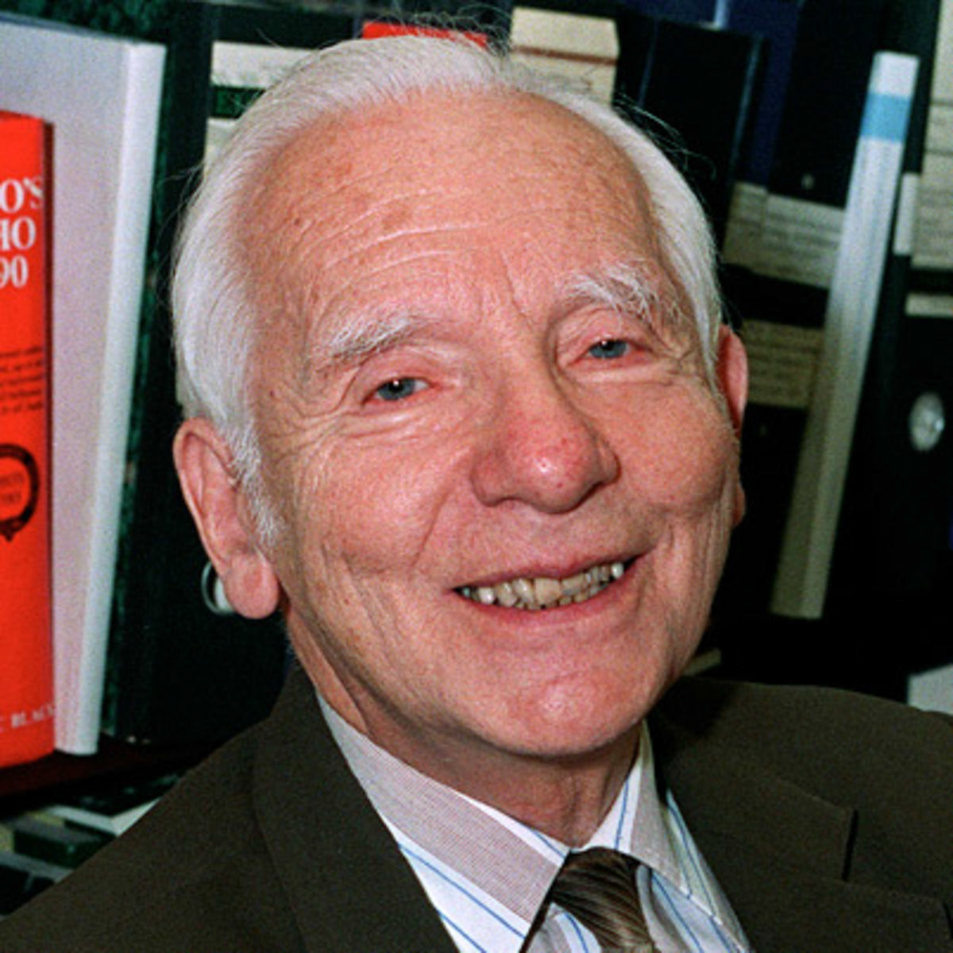

War II came, he was in Liverpool, in England. Much of Warsaw was destroyed when Poland was invaded, and he never saw his family again. Later, he was encouraged to join the Manhattan project, which developed the Atom Bomb; but while at Los Alamos he overheard the top-brass there saying that the objective of the project was not to target Germany, but to limit the expansion of the Soviet Union after the war was over. He was so shocked on hearing this that he left the Manhattan project – the only person to do so on conscientious grounds. Then, back in Britain he became a medical physicist. From a base as Professor of Physics at one of London’s medical schools, in 1957, he started a series of meetings, initially at a town called Pugwash, in Nova Scotia, Canada. This brought together top nuclear scientists from both sides of the Iron Curtain, in greatest secrecy, to discuss nuclear disarmament and non-proliferation. It has been said that at the most dangerous moments of the Cold War, Rotblat and the Pugwash group played critical roles in preventing actual conflict with nuclear weapons. In 1995, Rotblat and the Pugwash movement were awarded the Nobel Peace prize. His Nobel lecture, given in December of that year, was entitled, ‘Remember your Humanity’. In ending his lecture, he suggested that research scientists should voluntarily give a public commitment to something similar to the Hippocratic Oath, as has long been a tradition for medical people, on graduating: I quote: ‘The time has come’ Rotblat said ‘to formulate guidelines for the ethical conduct of scientists, perhaps in the form of a voluntary Hippocratic Oath. This would be particularly valuable for young scientists when they embark on a scientific career.’
My suggestion, for your consideration, then, is that there should be a similar form of public declaration of ethical commitment, adjusted to the circumstances, applying to health administrators, as they take up their public role, whether or not they are themselves medical graduates.

The Gestalt Principle.
I am drawing this lecture to a close. There is a theme uniting most of what I have been saying: A major figure of European science in the nineteenth century, was Ernst Mach. He was professor of Physics at Charles University in Prague. He was one of the sources upon which Albert Einstein drew, in developing his Theory of Relativity; but Mach’s achievements were not limited to physical sciences: He was also a pioneer in sensory physiology and psychology. Some of his writings include interesting statements anticipating what Wernicke was to write about how the brain constructs personal identity. He was also a forerunner of a style of psychology which blossomed in Germany between the two world wars – Gestalt psychology. The key phrase from Gestalt psychology is perhaps familiar – ‘The Whole is Greater than the Sum of the Parts’. This is a mis-translation, which seems to make it all a matter of quantity. A better translation is ‘The Whole is Different from the Sum of the Parts.’ In other words it is saying that you cannot reduce qualities to quantities. In Gestalt psychology, this principle was applied mainly to sensory perception. So – when I recognize a person by his or her face – I do not do it by recognizing the different parts of their face first, and then adding them together. I achieve this remarkable feat ‘as a whole’.
In my view, for biomedical sciences, the Gestalt principle is every bit as revolutionary as advances in physical sciences made between 1890 and 1940; but it is intrinsically non-mathematical, and non-quantitative, more on the limits than the possibilities of scientific reasoning. For this and other reasons, it never gained the status that revolutions in physics did at that time. However, the basic principle that ‘Wholes cannot be grasped just by adding the parts’ can be used as a guide in many areas beyond sensory perception: In how our sense of being ‘a person’ is built by assimilating memories of many component experiences; in personal healing from mental disorder; in relationships between people, where each individual is but one component of a complex team effort, the best often achieved not by one person forcing his way, but by accepting that he or she is part of an entity bigger than themselves; in constructing healthcare systems where diverse experts have different, yet complementary roles. I suspect that such intrinsic holism resonates well in East Asia, as it does in many non-Western societies around the world – including, may I say, the Maori of New Zealand, the original Polynesian people of my adopted country.

Conclusion: Thomas Traherne ‘The Salutation’
So, I conclude, again on the theme of healing: healing for fragmented persons, and fragmented social groups. For me, the best expression of a whole person is through music, and if I were Maori in New Zealand, at this point I might break out into song. I will spare you that! Instead, I want to read a poem. It is one I have known since teenage years and means a lot to me. The poet was Thomas Traherne. He lived in the seventeenth century, an ordained minister of religion, spending most of his time on the Welsh borders, a bit west of Hereford. He should probably be classed with the group of poets at that time - the ‘metaphysical poets’. However, Traherne’s work was completely unknown until the latter part of the nineteenth century, when, somehow it was discovered, I think in a second-hand bookshop. That in itself symbolises one of my messages, the attempt to uncover previously hidden wisdom, to enable the strengths of stigmatised individuals, and stigmatised professions to emerge, as if from beneath a shroud. I came to know this poem at school as a teenager. I studied Advanced-level music, and one of our ‘set works’ was by a very good, but lesser-known twentieth-century British composer, Gerald Finzi. His work - Dies Natalis, or ‘Day of Birth’ was a setting for voice and string orchestra of various poems of Traherne, which were relatively new discoveries at the time his music was written. The poem, with which I want to finish, was used by Finzi as the last movement in his song cycle. It is called ‘The Salutation’. It is really a reflection on the mystery - some would say the miracle - of human existence; yet it is also most appropriate in the context of recovery from a disorder of the mind, once supposed to fragment human personhood itself. So - ‘The Salutation’, by Thomas Traherne:

The Salutation

These little limbs
These eyes and hands, which here I find
This panting heart, wherewith my life begins
Where have ye been? Behind
what curtain were ye from me hid so long?
Where was, in what abyss, my speaking tongue?

When silent I
so many thousand thousand years
beneath the dust did in a chaos lie.
How could I smiles or tears
or lips or hands or eye or ears perceive?
Welcome, ye treasures, which I now receive.

I that so long
was nothing from eternity,
did little think such joys as ear or tongue
to celebrate or see:
Such sounds to hear, such hands to feel, such feet,
Beneath the skies, on such a ground to meet.

New burnished joys,
Which yellow gold and pearls excel!
Such sacred treasures are the limbs in boys
In which a soul doth dwell:
Their organized joints and azure veins
More wealth includes than all the world contains.

From dust I rise
And out of nothing now awake;
These brighter regions which salute mine eyes,
A gift from God I take.
The earth, the seas, the light, the day, the skies
The sun and stars are mine if these I prize.

Long time before
I in my mother’s womb was born,
A God preparing did this glorious store,
The world, for me adorn.
Into this Eden, so divine and fair,
So wide and bright, I come His son and heir.

A stranger here
Strange things does meet, strange glories see:
Strange treasures lodged in this fair world appear
Strange all, and new to me.
But that they mine should be, who nothing was,
That strangest is of all, yet brought to pass.

