**Supplementary document no 6 for Chapter 7**

**Pages 268-281 from ‘Family Jewels’ files from CIA, followed by details of my analysis**

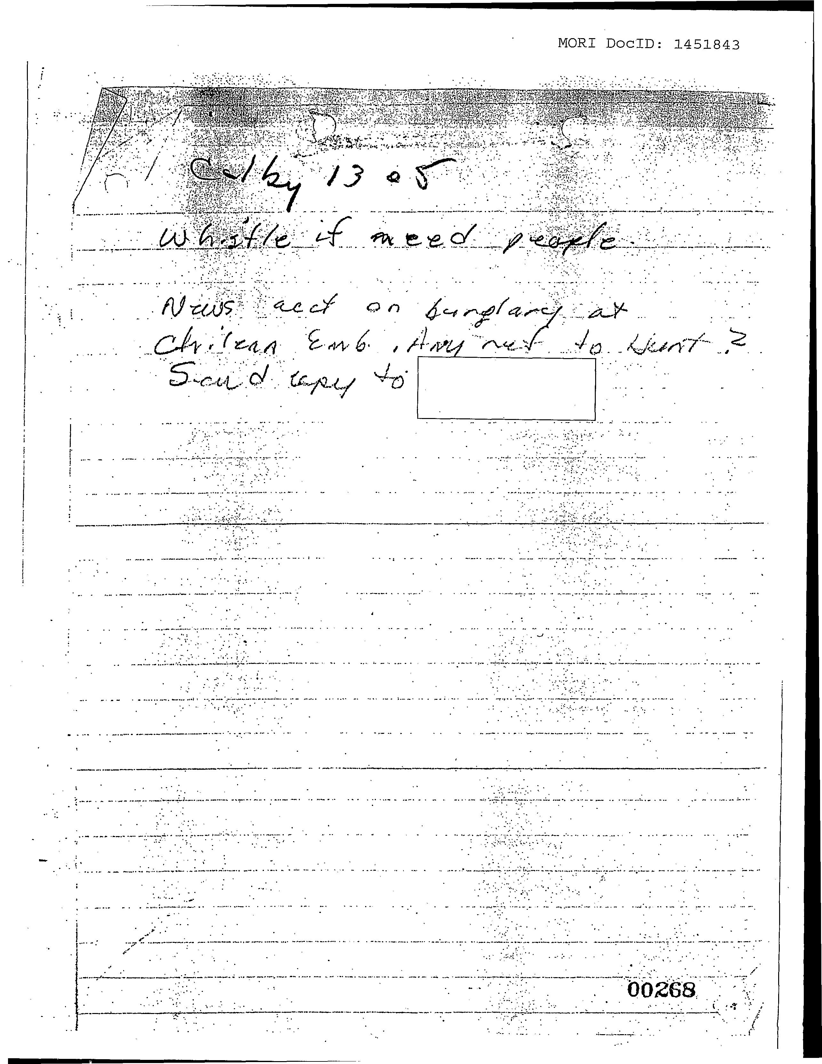

~. "~-~

~

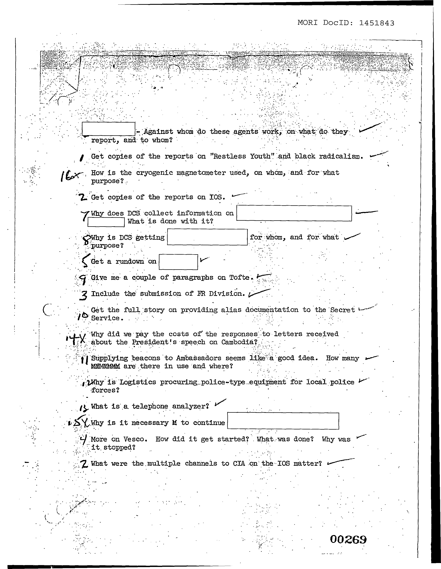

'

~.

.  
 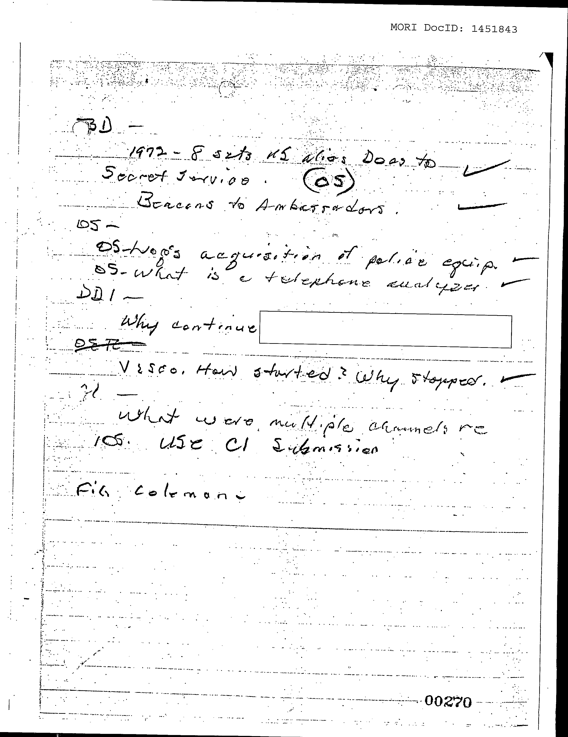

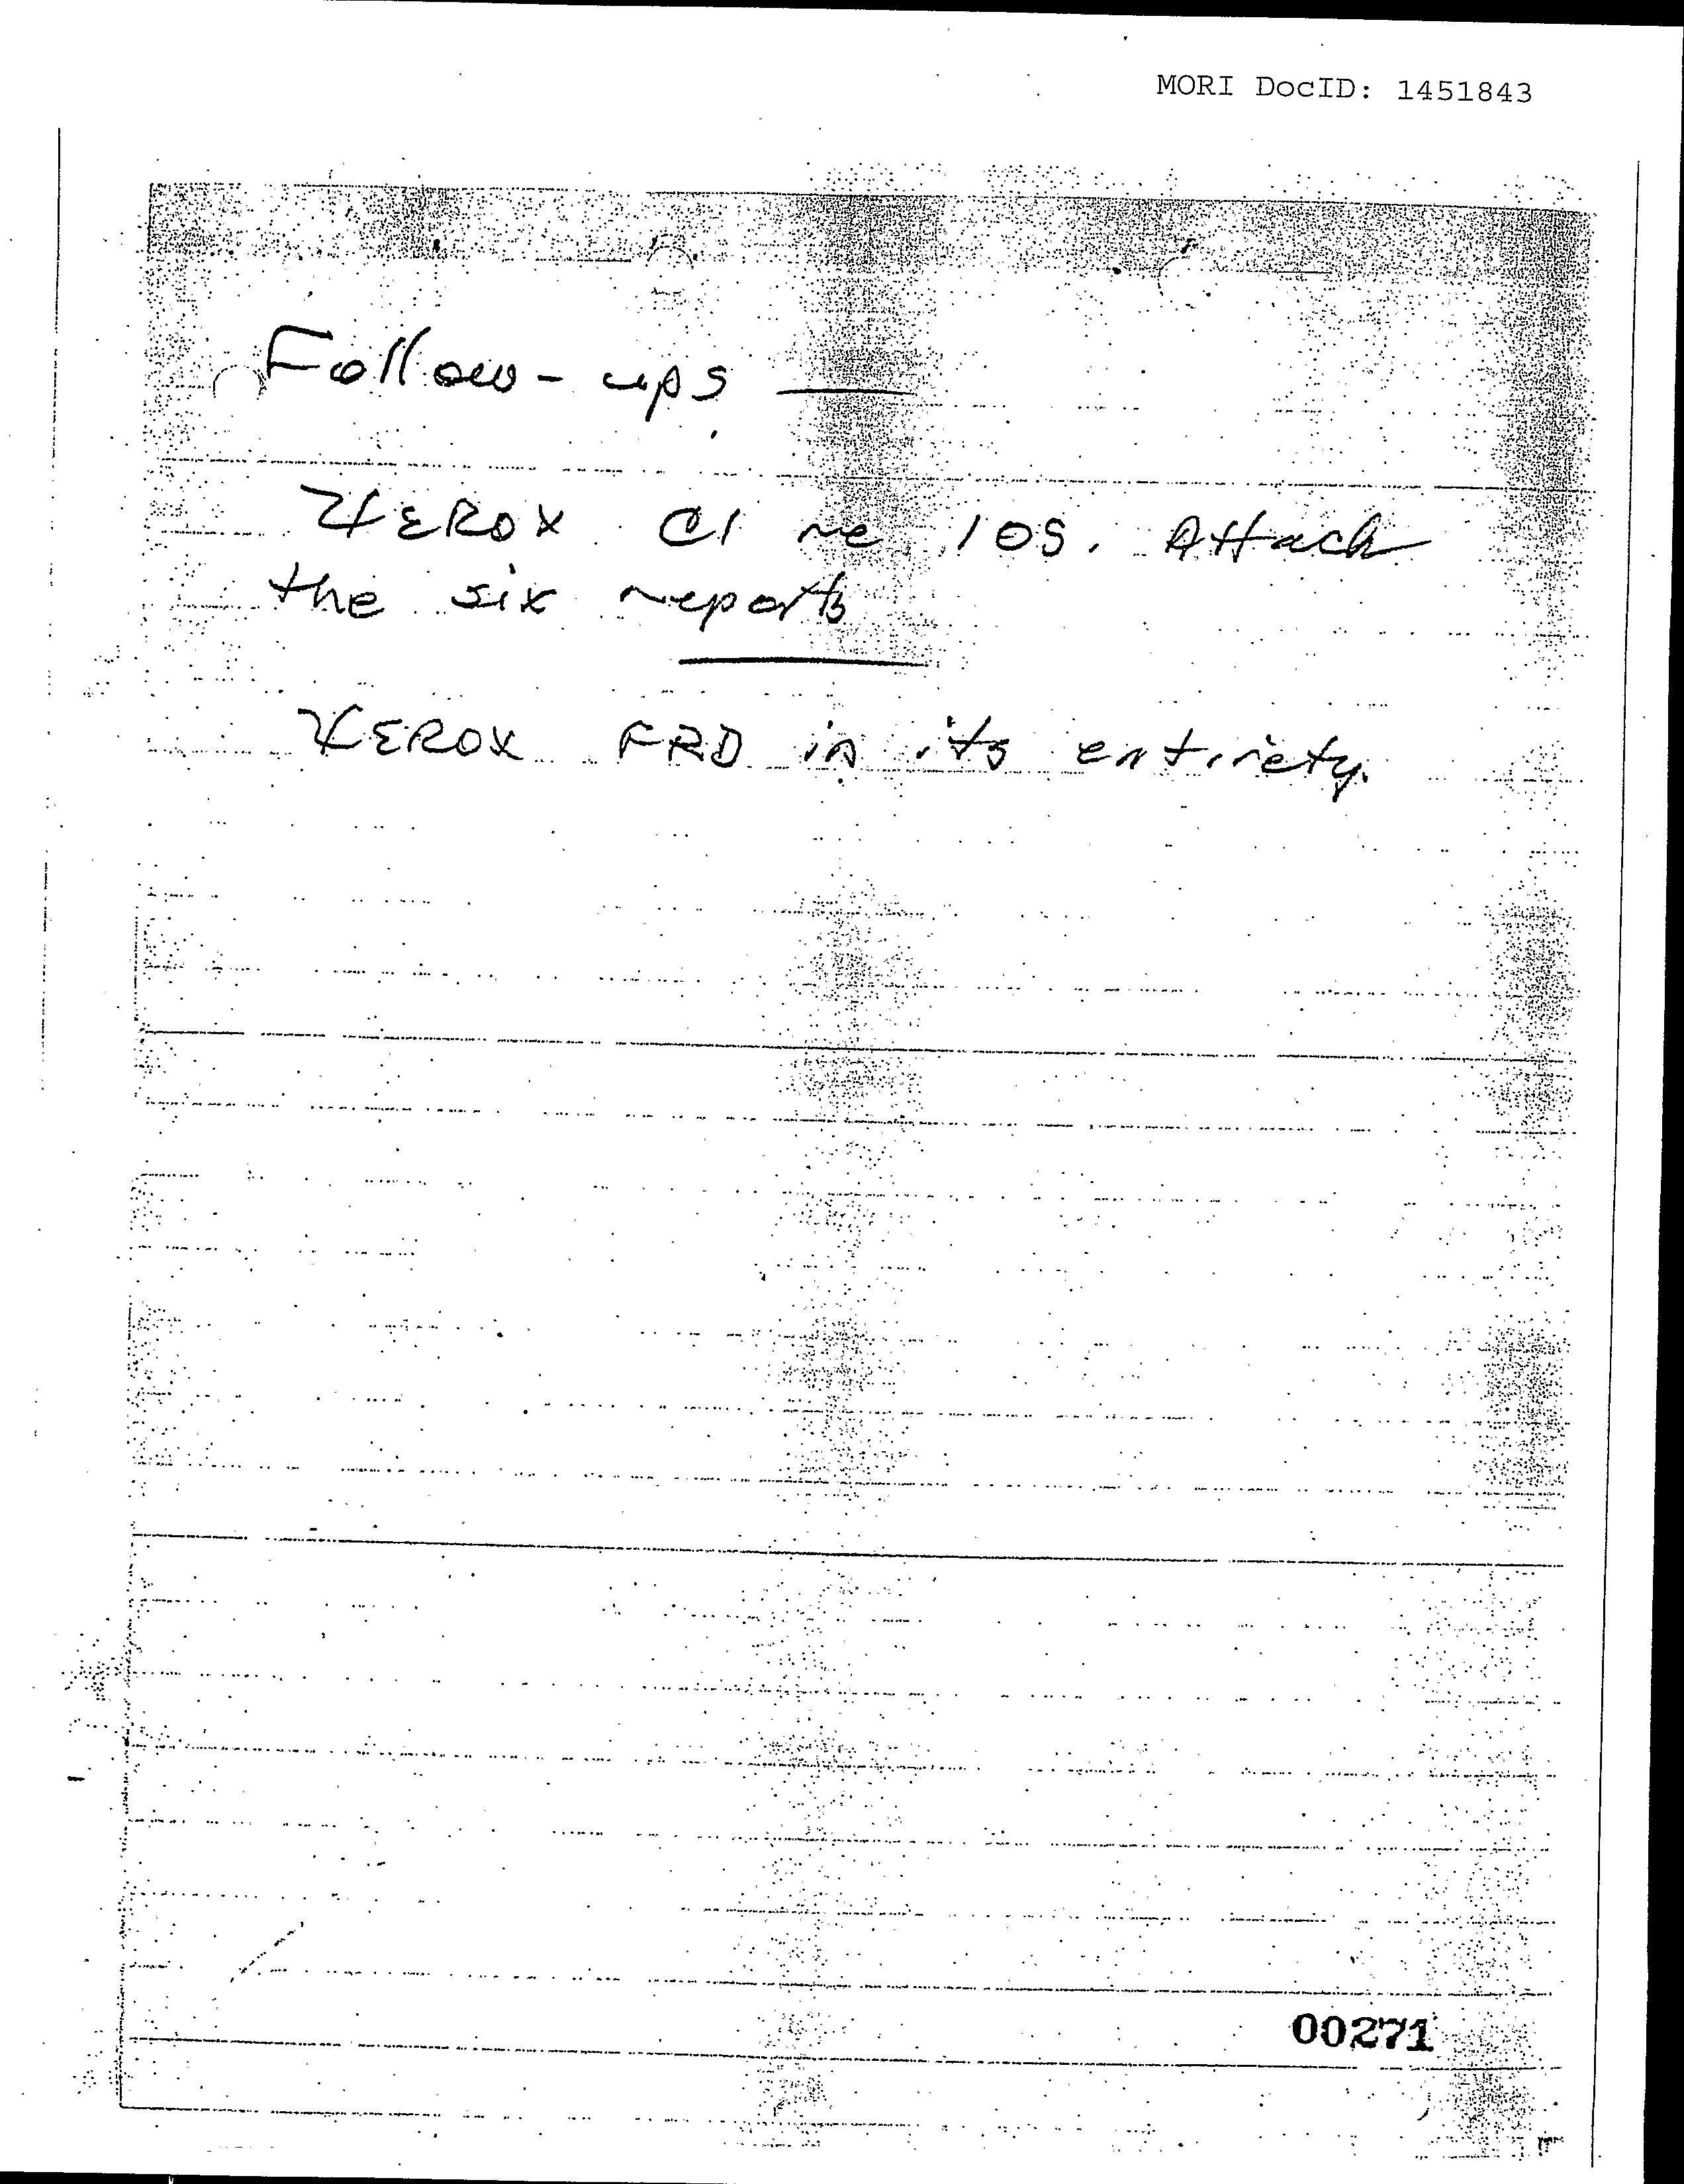

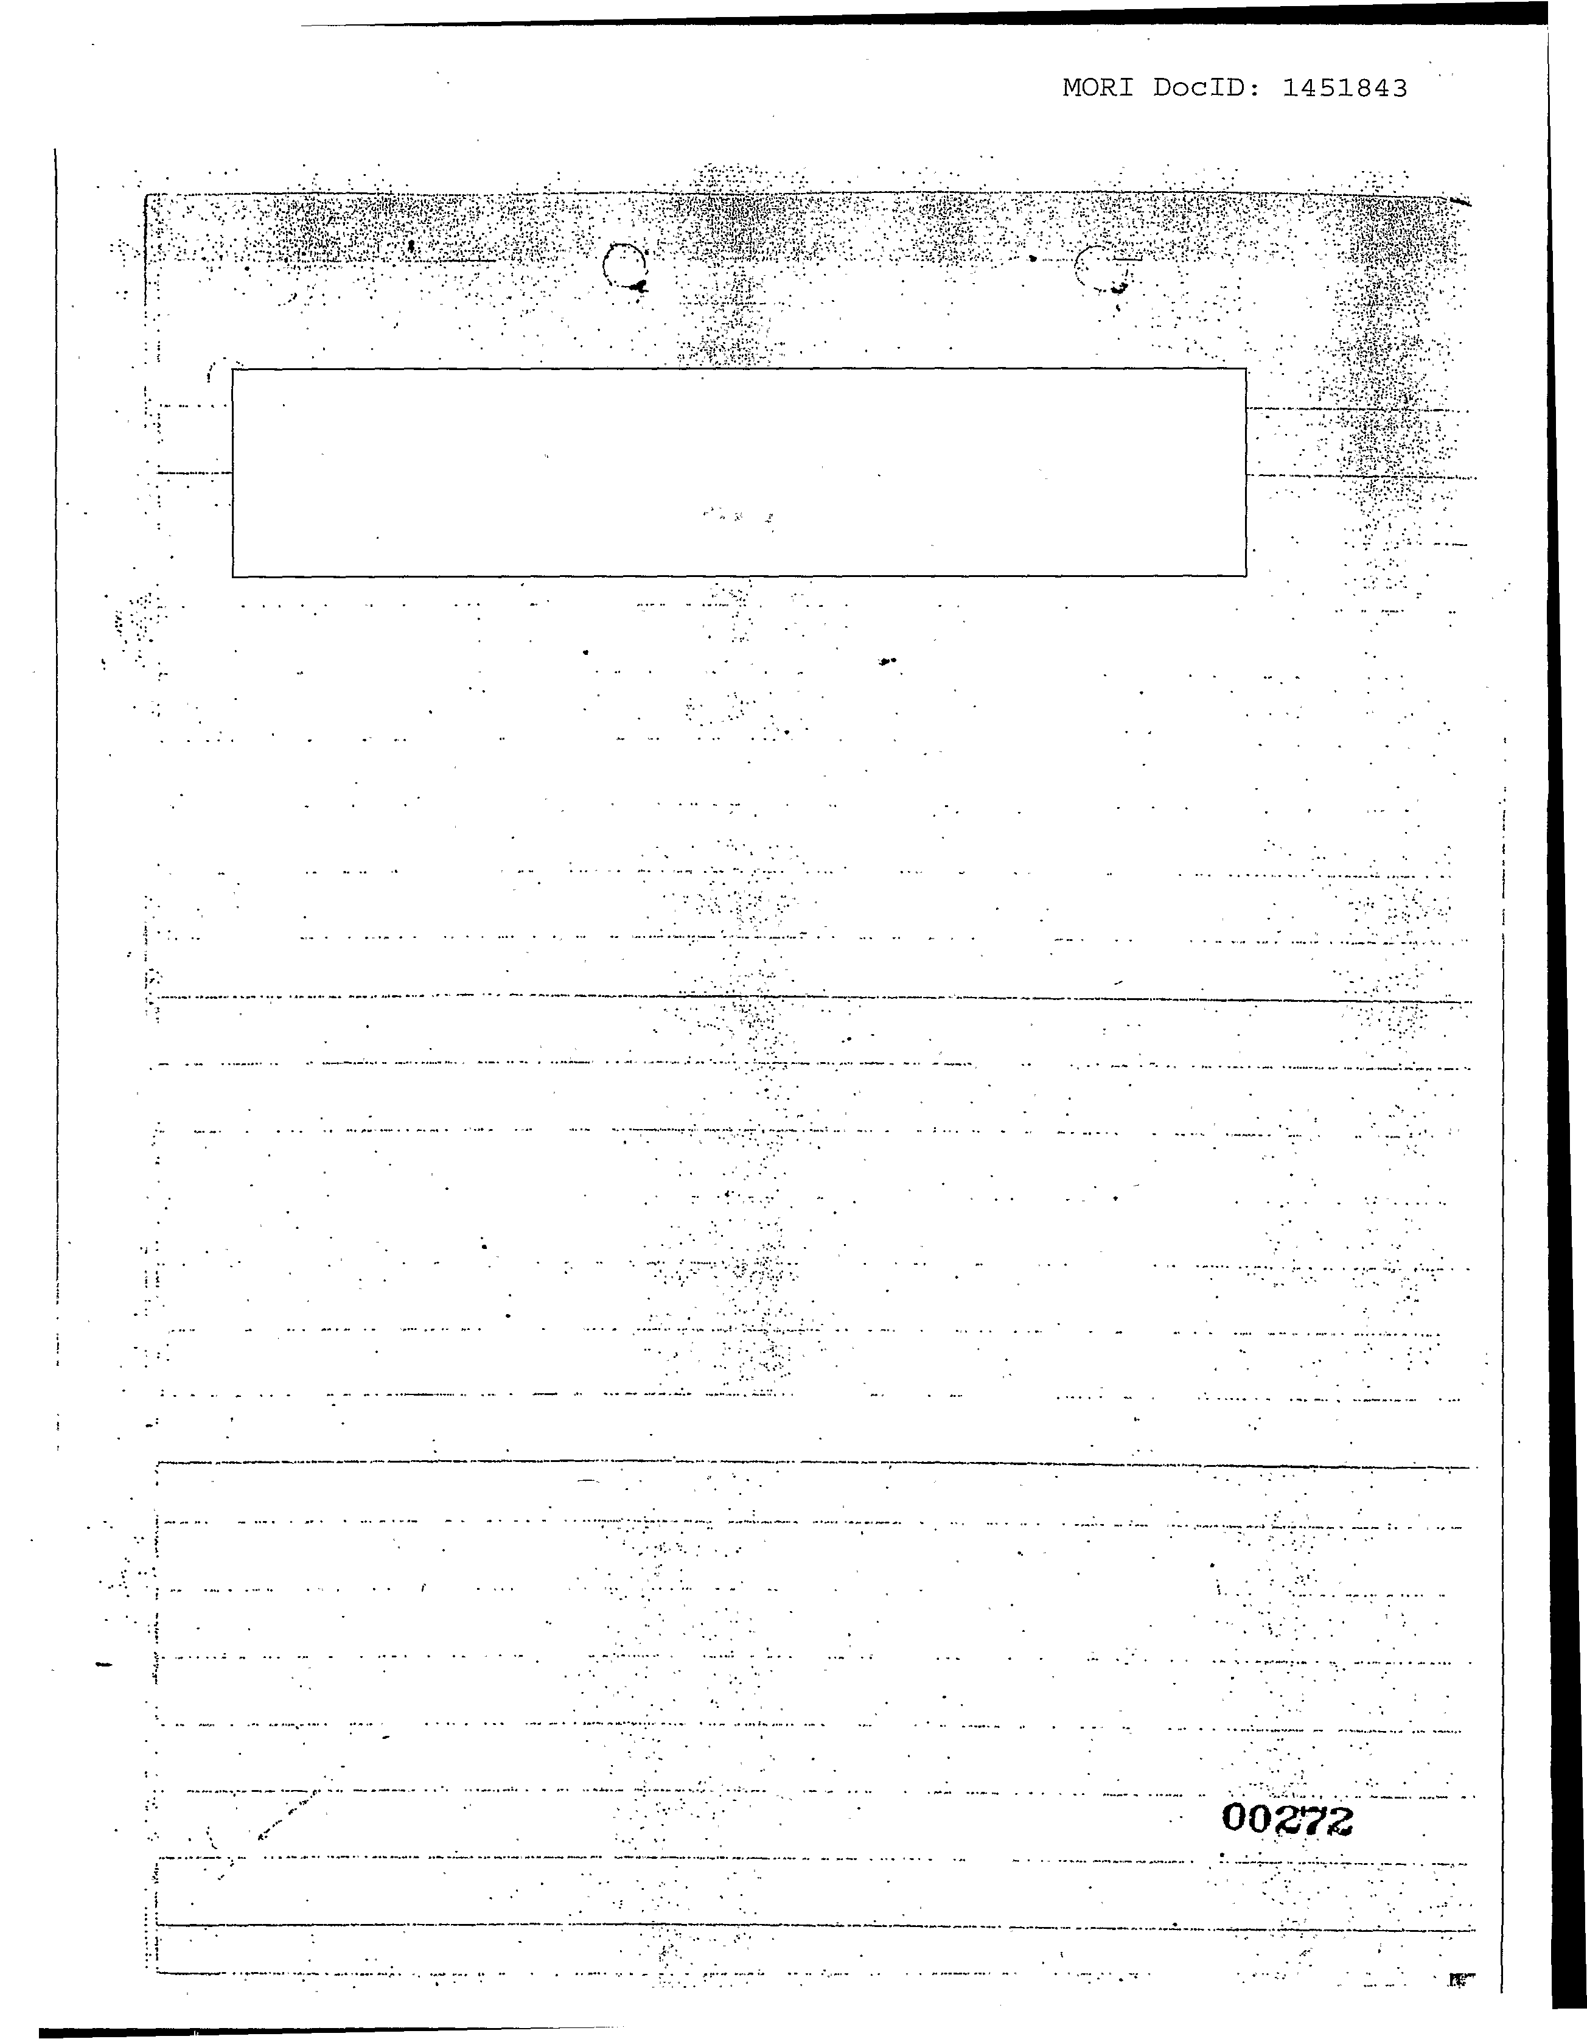

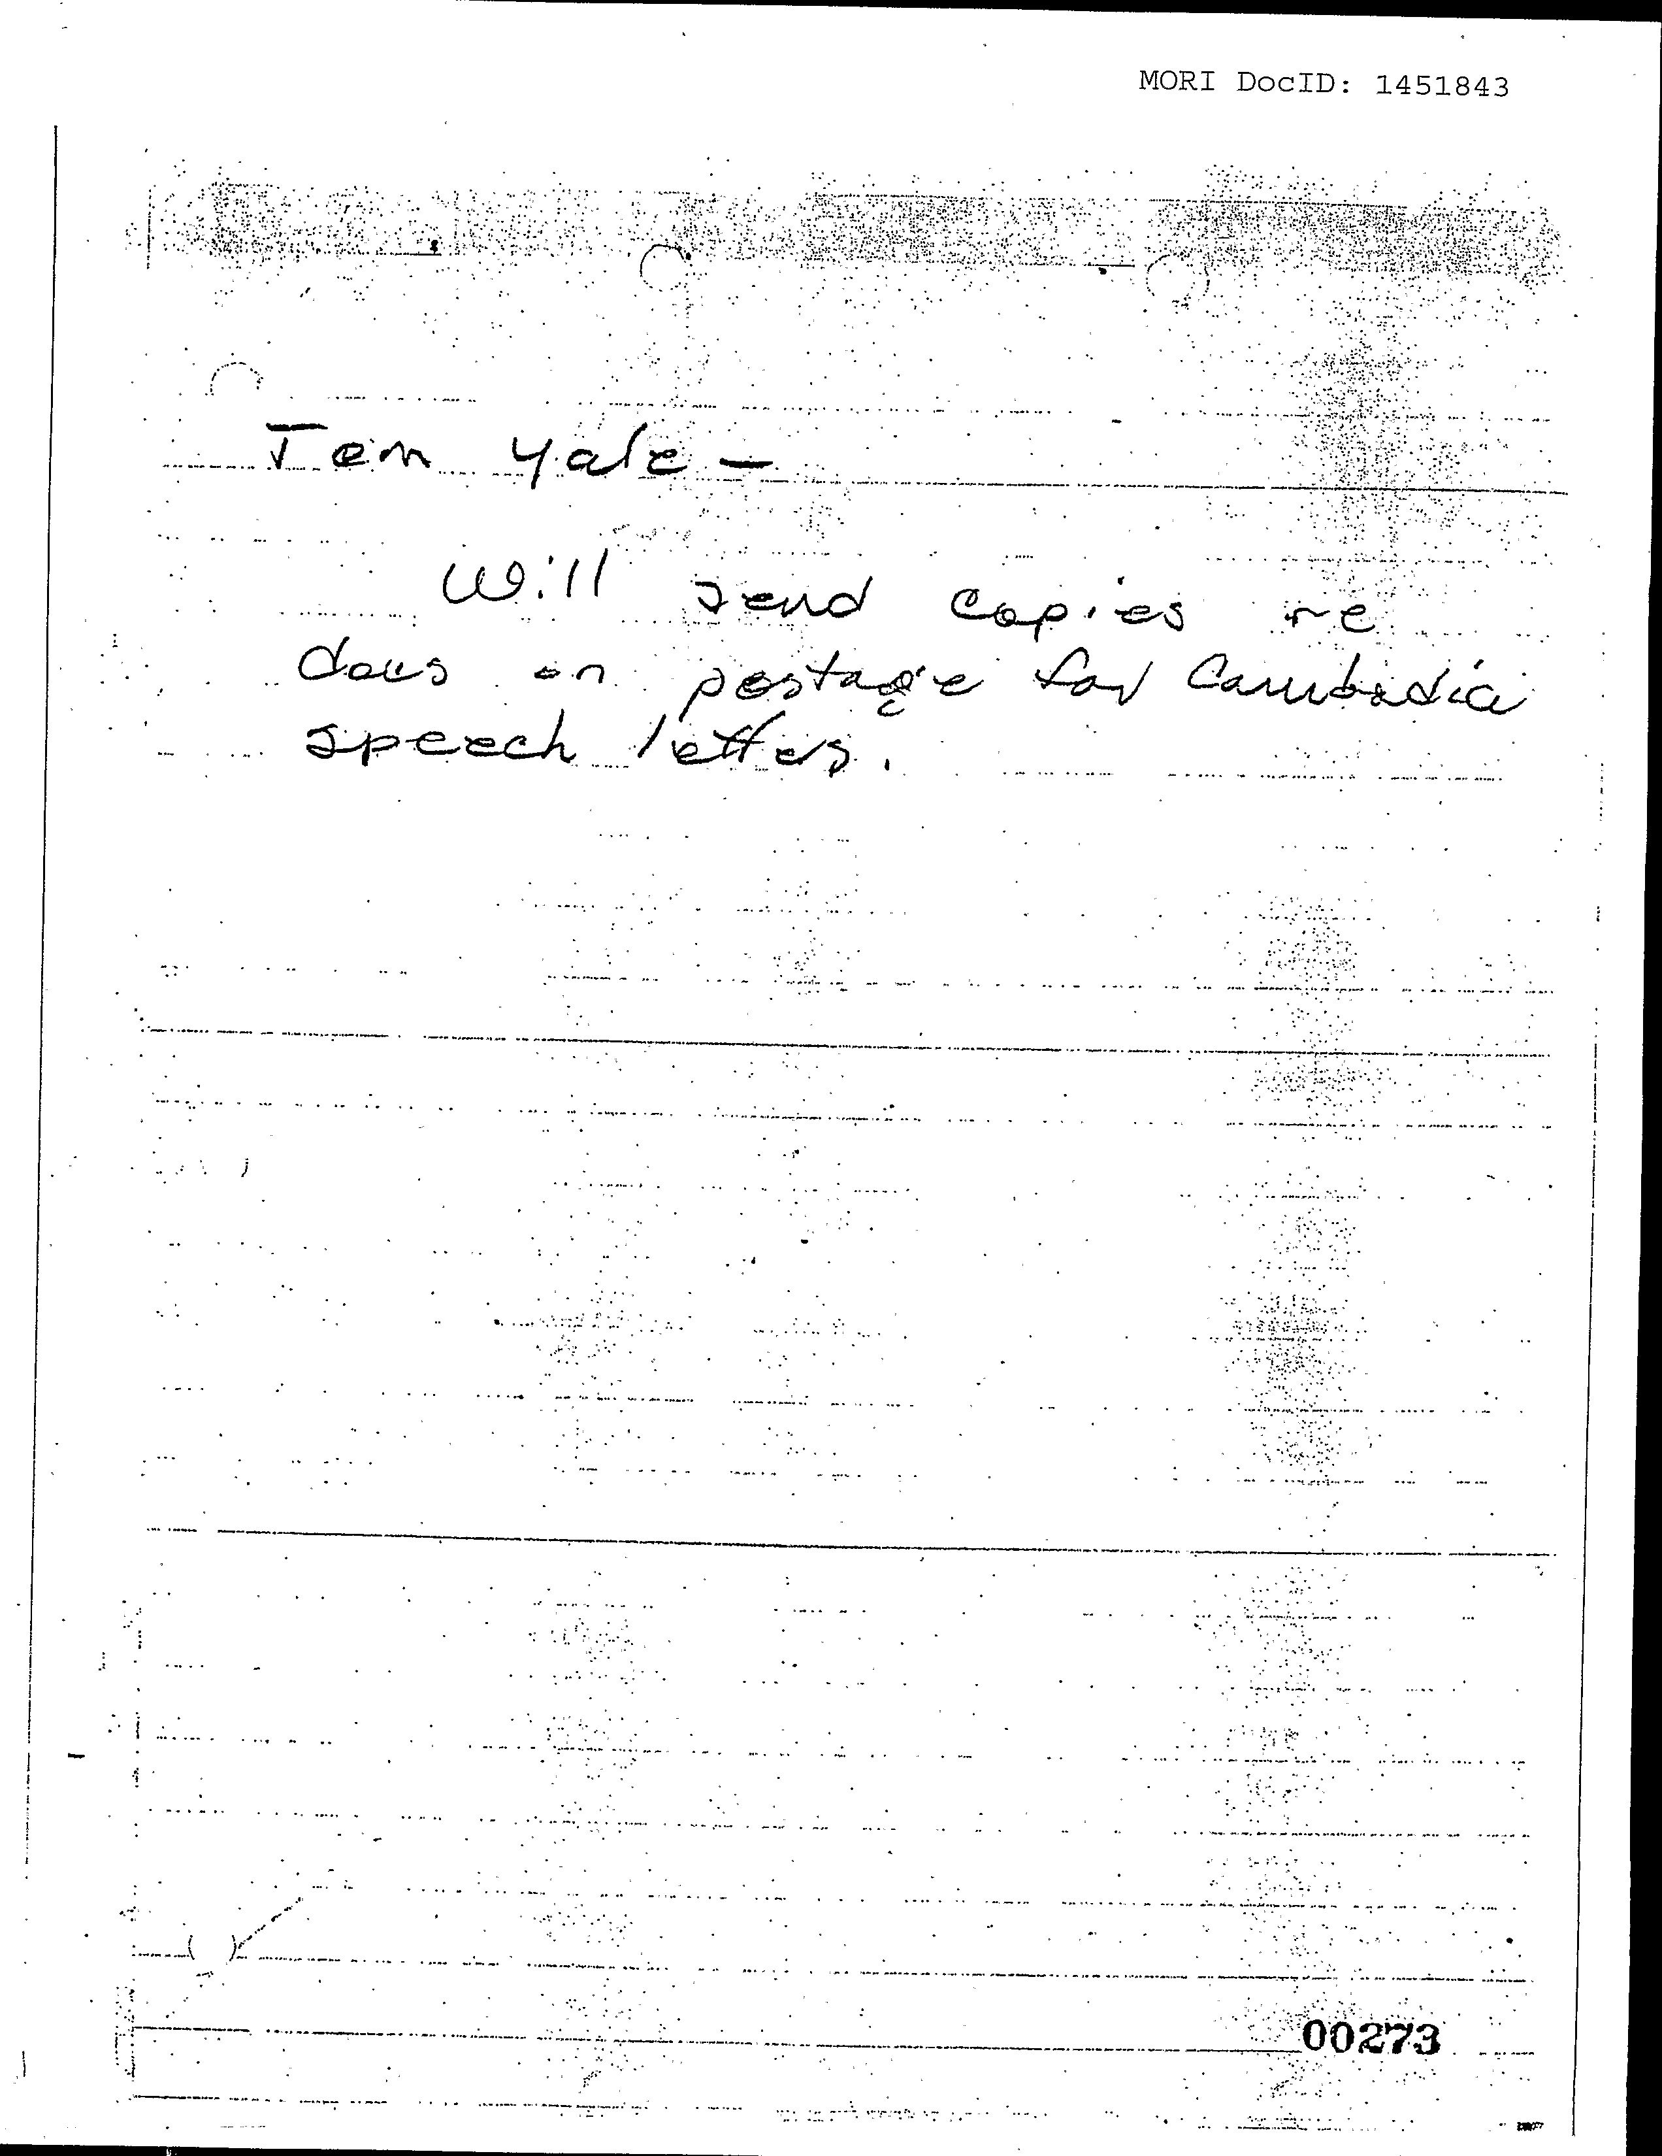

_ _ _

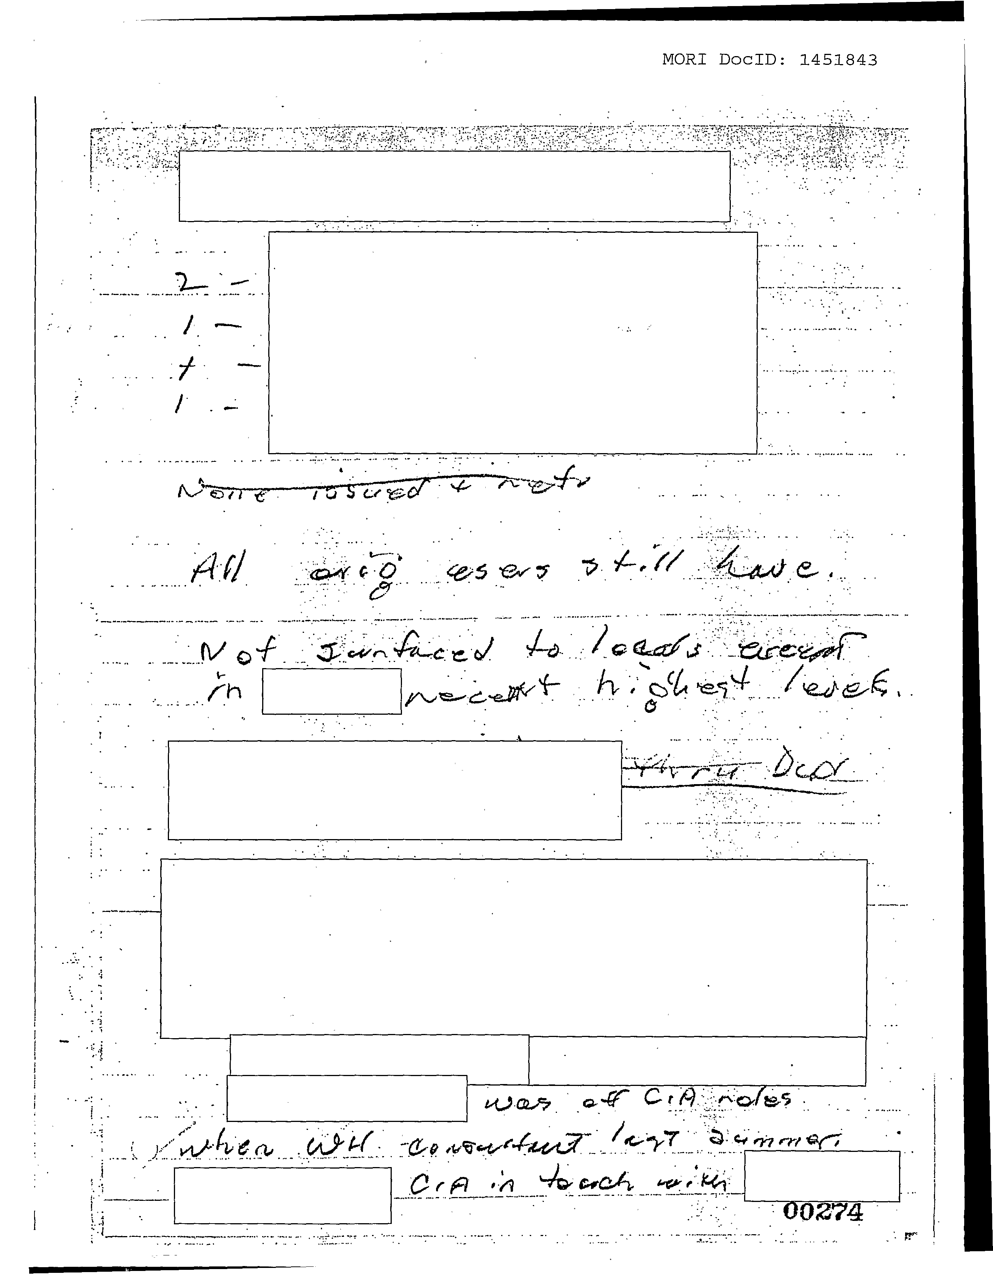

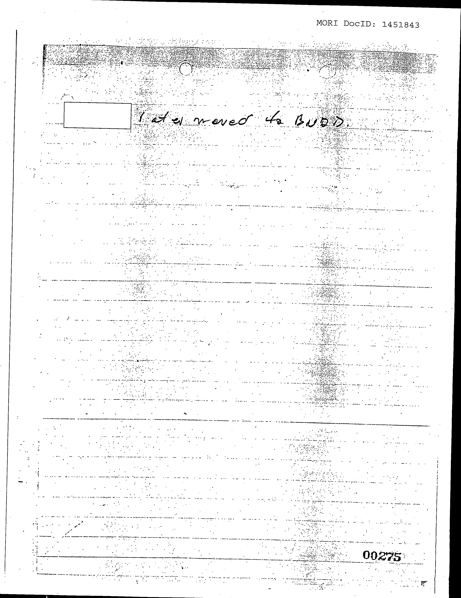

*I'"*

.;

~_. _~_._ ..__..~

. _

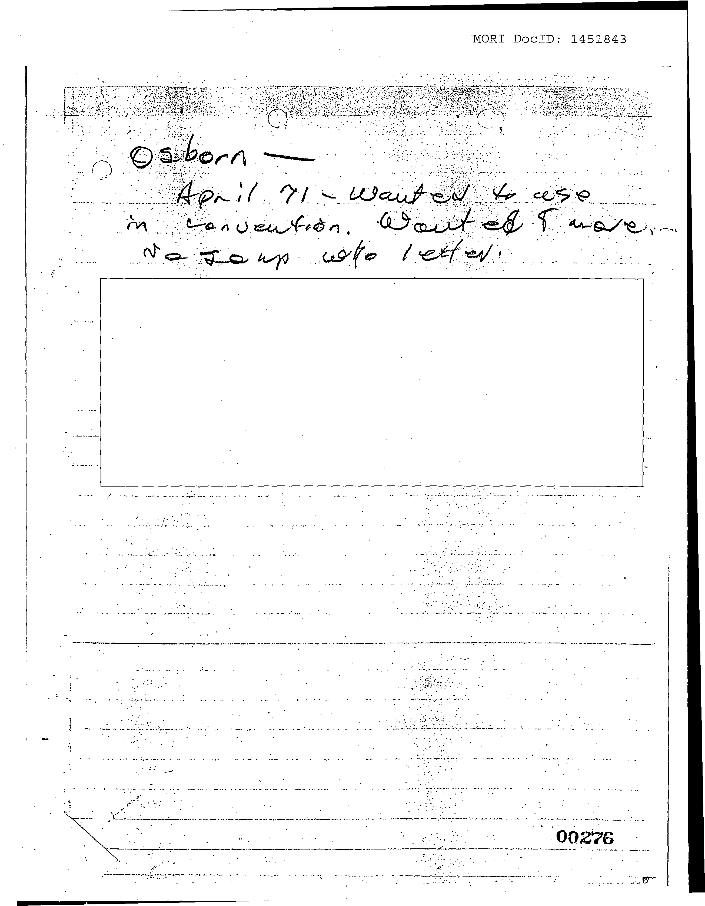

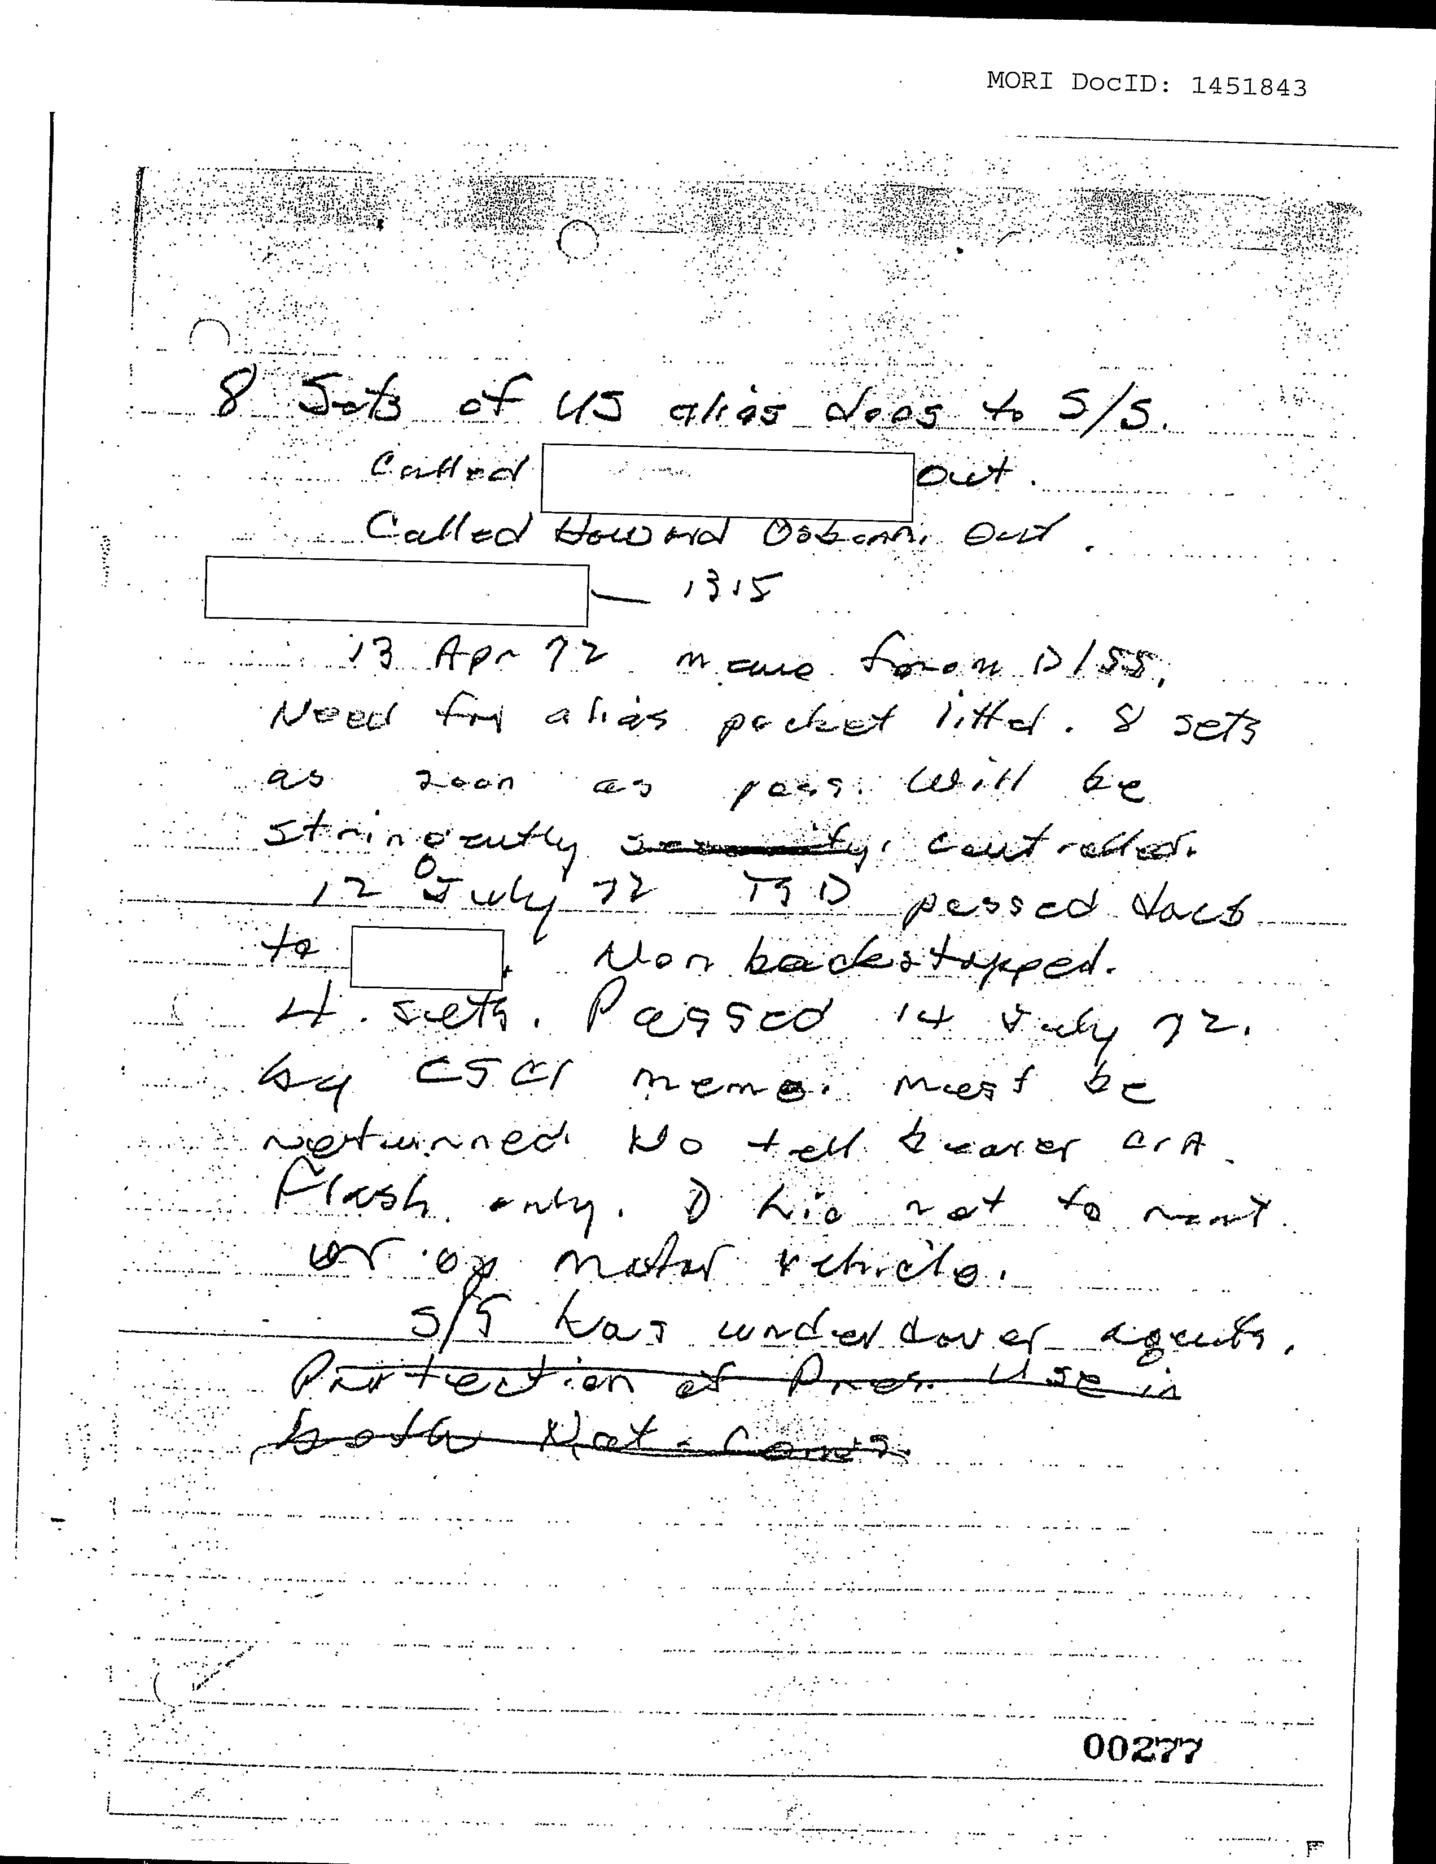

•.~--t~.--'.. .".•_'"..•~.. .. <.0 OM •

•• ••

••

~"" •

'~"- -~

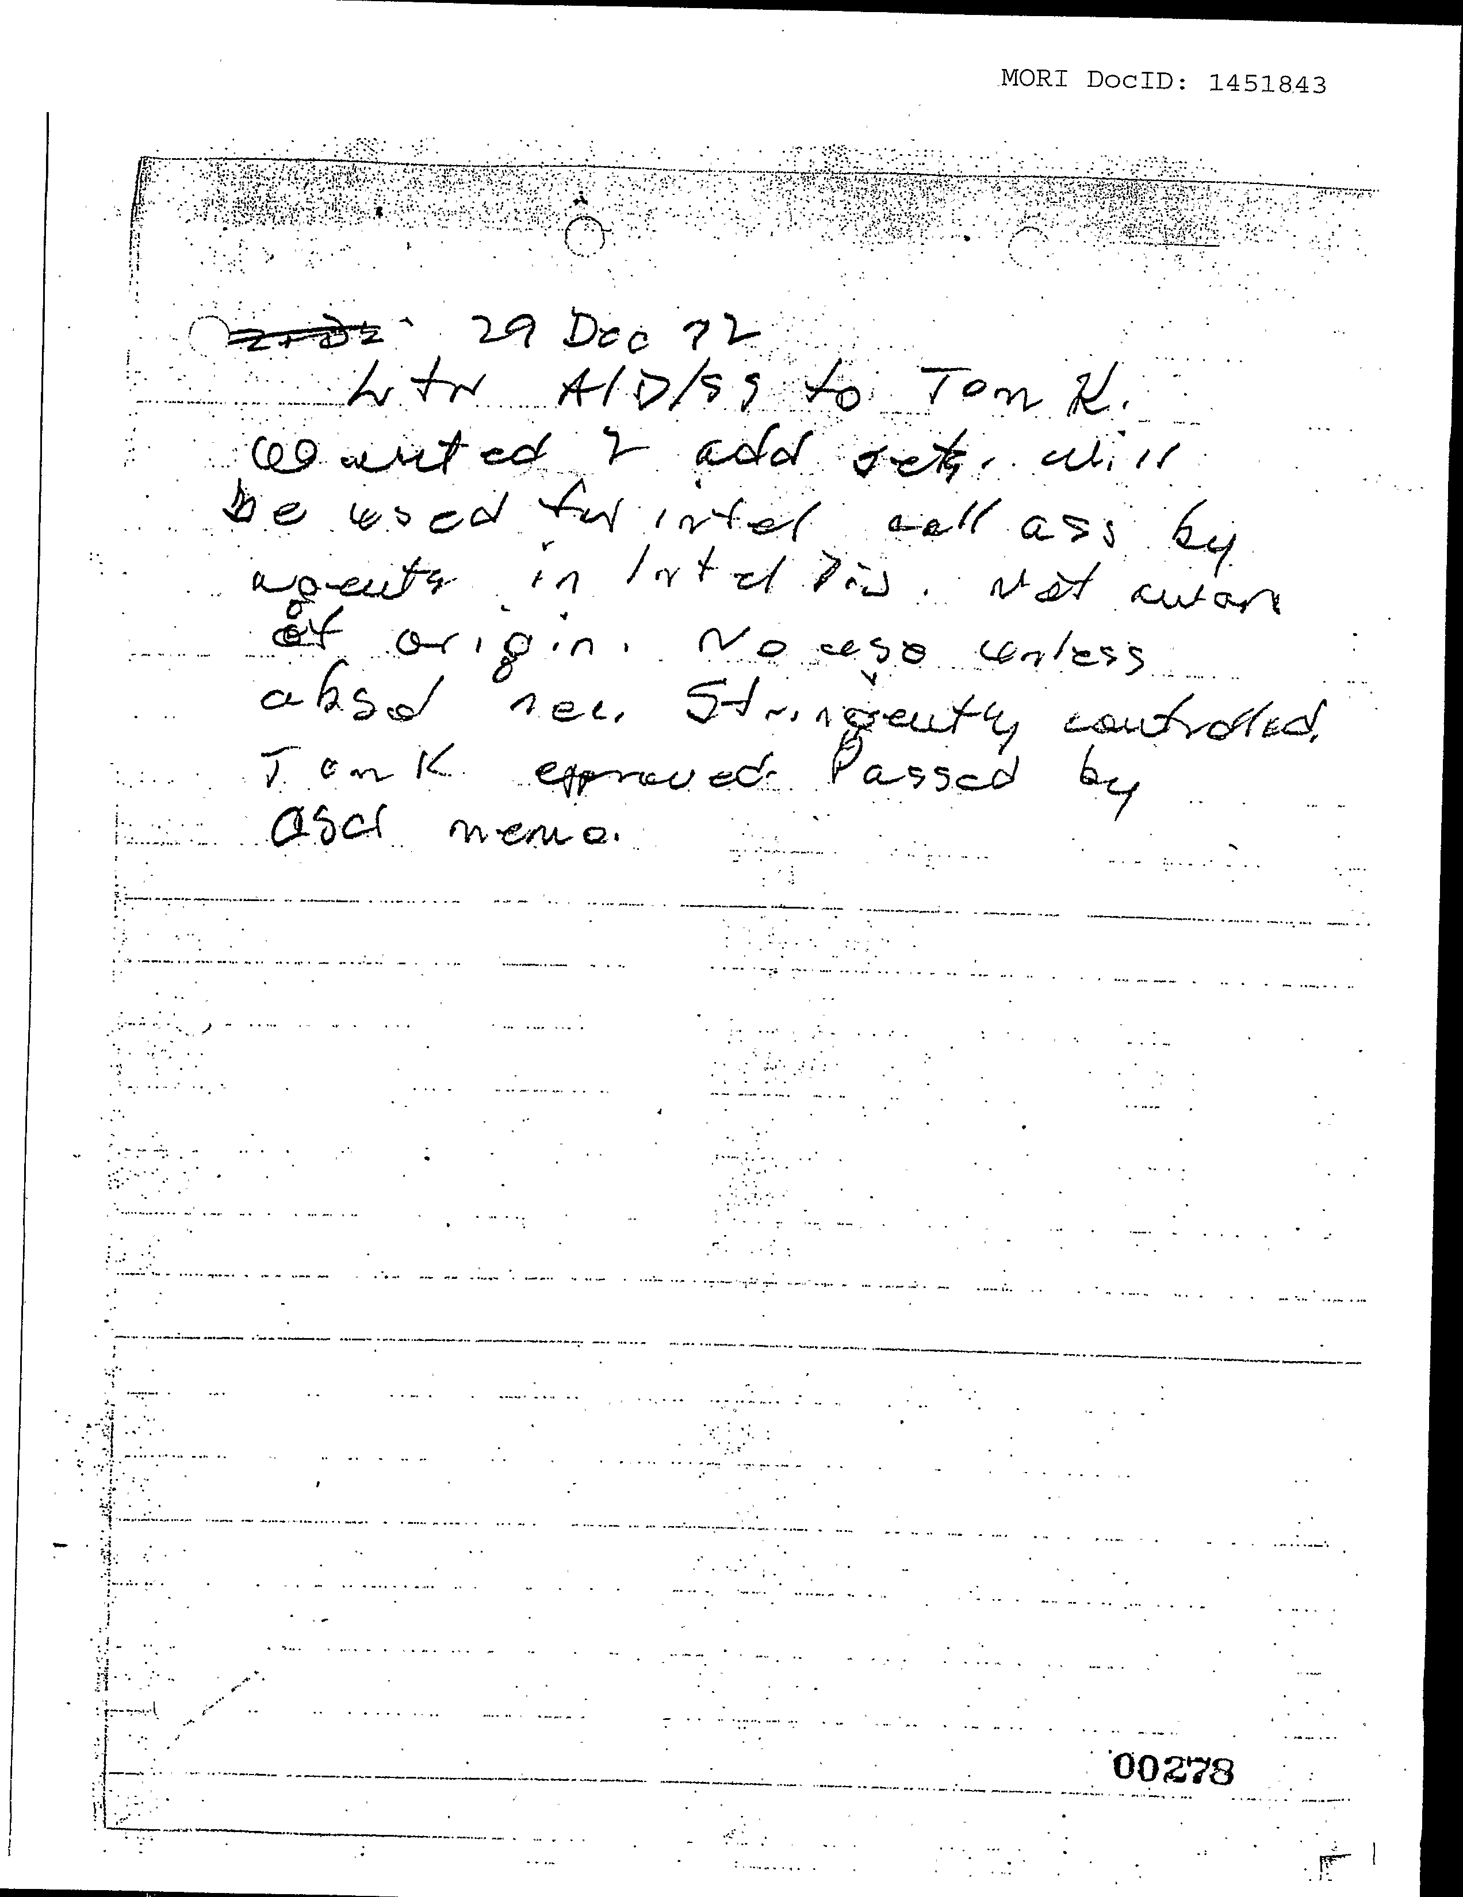

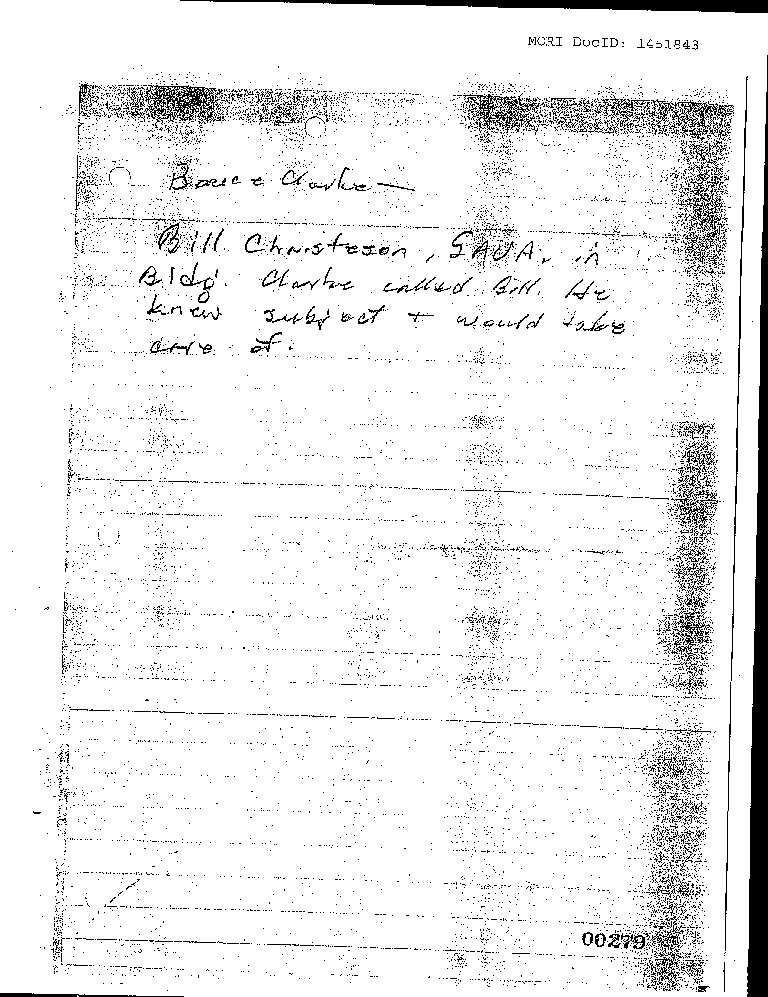

:":.:

-,'.;,:_~/".:';,.'

. . ::-:)..'... :"-

:..'~ -:... -"

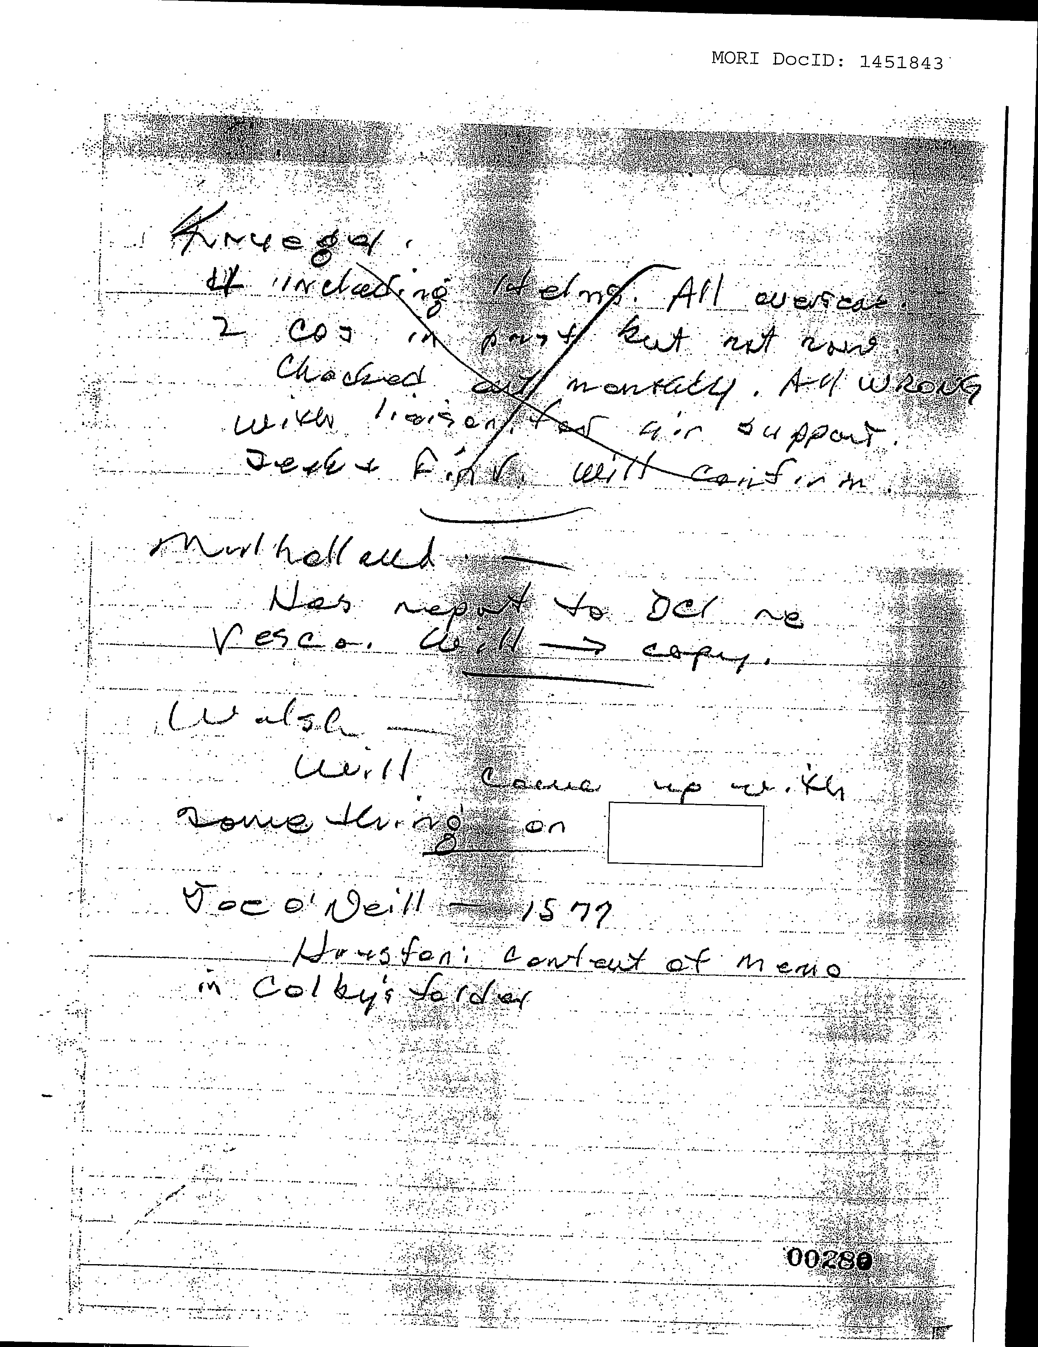

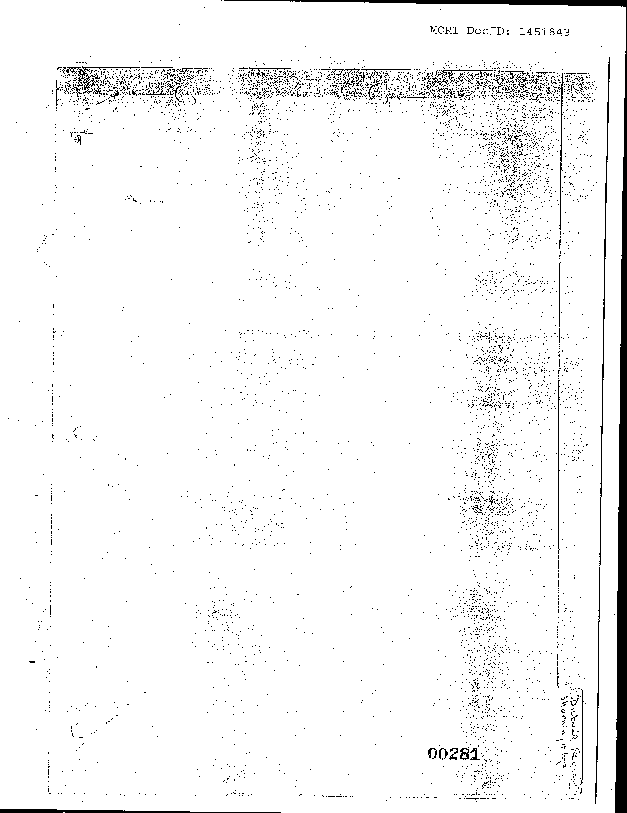

i •j

**·-1 :" :**

I

**Analysis of Draft Notes on Planning Meeting**

**(‘Family Jewels, pp, 268-281)**

This analysis is complex and difficult, but important. Individual parts of it are ambiguous (partly because of illegibility, partly because of abbreviation or acronyms whose meaning is not obvious. However, in the same way that a mathematician can solve equations with several unknowns, provided he has several simultaneous equations to work from, most uncertainties can be resolved, if a large enough frame of analysis is used. For this reason, my analysis covers these thirteen pages, in two forms. One is a page-by-page analysis, the other is a topic-by-topic analysis. I also occasionally refer to use detail in other parts of the Family Jewels file, to help resolve ambiguities. To help the reader connect the analysis with Chapter 5, and other main chapters, the topic-by-topic analysis comes first, really am amplification of points already included in Chapter 5. The page-by-page analysis which follows is then almost an appendix for those dedicated sleuths/scholars, who want to check my inference in all possible detail.

**Part I: Analysis By Topic**

***Reporting to William Colby*.** P. 268 begins with the name ‘Colby’, clearly spelt. This is William Colby, future Director of CIA. What follows appears to be ‘hot news’ from Colby, probably conveyed by him, before the business of the meeting began. Colby had recently been one of the CIA’s chiefs in Vietnam, with oversight over Operation Phoenix. On return to Washington in 1971, the position of Executive Director-Comptroller was created for him by Richard Helms. At the time of the meeting I assume he held this position. The title ‘comptroller’ supposedly indicates that he supervised the regularity of accounting and finance. In fact, his role was broader than this, to protect the CIA from unsettling allegations. Thus, even before Schlesinger’s appointment, his ‘purge’, and the collection of the ‘Family Jewels’ dossier, Helms was aware that the CIA had become very vulnerable. By appointing Colby, he was taking steps to safeguard it from embarrassing disclosures. This helps understand much of the agenda and subsequent notes on this meeting. As the Watergate crisis unfolded, Colby became the CIA's front man to the press, as well as testifying before Congress and impeachment committees[1].

***A Planning Meeting*:**

* The notes had neither heading, date nor signature. However:
* Scanning the notes suggests that the meeting was not about *decisions* for forthcoming plans but about *implementing* those already made by higher command, on diverse topics.
* The typescript and formatting of the agenda are similar to a shorter agenda list (p. 415 of the Family Jewels file), and some of agenda items were very similar to those in p. 269.
* This second list begins *‘22 May 1973’ . . . ‘Memorandum for the record’. . .‘Subject: General: Family Jewels Exercise’; Specific: Meeting with Colby on this date’*. It continues: ‘*Broe and [redacted] met with Colby 11.15 hrs today. Colby asked that we provide him with fuller information on the following items.’*
* On p. 149 is a memo from Charles A Briggs, Director, Planning, Programming and Budgeting dated 23 May 1973, and ending with: *‘5. I held a staff meeting yesterday to pass the request to all OPPB employees’.* 23 May was the day after the meeting whose agenda appears on p.415. The ‘yesterday’ probably refers to the meeting on 22 May, whose agenda is on p. 415.
* ‘*Broe*’ (Willian V) at this time was Inspector General of CIA.
* I strongly suspect that ‘redacted’ in the second agenda list name was Briggs
* *I infer that the meetings whose agendas appear on pp. 269 and 415 were both called by Colby, to discuss matters to be actioned in Briggs’ office.*

***The Date of the Meeting*:**

* On p.268 after the name Colby, the writing clearly reads ‘*13.05’*, presumably a date, followed by ‘*News acct on burglary at Chilean emb’.*
* Between 5 April 71 and 15 May 72 there had been four break-ins at the Chilean embassy in Washington DC. (The other two occurred on 11 April 1971 and 10 February, 1972).
* Elsewhere in the Family Jewels file, there is evidence that the last break-in was initially thought to have occurred on 13 May (e.g p. 376). This was based on a police report written in the late afternoon of 15 May, but projected back to the early morning of 13 May. This back-dating was incorrect and was corrected later (pp 381-384.): The break-in actually occurred early in the morning of 15 May.
* The significance is that the note on p. 268 suggests that the meeting occurred before the mistake was identified, and therefore close in time to the initial incorrect report of 15 May.
* *I therefore conclude that they were notes on a meeting on either 15 or 16 May 1972.*

***Overview of Agenda*:**

* The 17-item agenda was unnumbered as typescript, but had non-sequential numbering inserted by hand. I implicitly number the items sequentially from top downwards
* The agenda list has many hints of a role for CIA supervising and monitoring rival agencies and protecting itself (items 1,4,5,6,7,8,9,11,16,17). This fits Colby’s *de facto* role as Comptroller.
* However there were other focal points:
* Overseas issues,
* Technical matters including those for surveillance,
* Clandestine activities of the Department of Defence
* Several financial topics.
* Item 9: ‘FR Division’ probably refers to. ‘Foreign resources division’ [e.g see p.455] ’.
* Items,11,12,16,17: are probably about overseas matters
* Items 3, 10,12,13,14, 15: Technical matters
* Items 10,12,13 & 14, appear to deal with methods of surveillance.
* Items 5 and 6, mention DCS: Directorate of Clandestine Services. This *might* refer to a branch of the Defence Intelligence Service (not CIA), but more likely an informal naming of the Directorate of Plans (within CIA).
* Several references to financial matters
* Payment by CIA related to correspondence over Nixon’s recent Cambodia speech[2] (see item 4, p. 273)
* Tom Yale (p. 273): Director of Finance.
* Item 4: IOS (Investment Overseas Service, and Vesco (item 16) Item 17 - ‘*Multiple channels on IOS matter’* - is about channels for *financial transaction.[3]*

***Overseas Operations***(including possible outreach of Operation CHAOS):

* On p.270 we read: ‘*1972 8 sets of US alias docs to Secret Service (OS)*’ and ‘*Beacons to Ambassadors’*. Item 10 in the agenda is similar, but without ‘OS’. ‘*Secret service’* could be part of US treasury, in service of the White House, rather than the CIA. However, the reference to ‘*US alias docs’* suggests it is a request for support overseas. OS (mentioned twice in next lines on p.270) is Office of Security[4], part of the Directorate of Support in CIA, an office not confined to domestic matters. ‘*Beacons to Ambassadors’* (also in item 12 of agenda) refers to overseas matters. I therefore take these two lines to refer to overseas activity of CIA.
* Pp.277-278 seem to be about future travel plans to the end of year 1972. The two pages seem to be in continuity, as judged by the sequence of dates across the two pages.
* On p.277 we read *‘13 Apr 72 memo from DISS, Need <?crossed out?> alias pocket litter. 8 sets as soon as poss. Will be stringently <word crossed out> controlled.’* ‘*DISS’* is probably Defence Intelligence System Service. What they needed was presumably to be used in an operation outside USA, Details which follow are – I think - part of routine disguise material.
* On p. 278 we read*’29 Dec 1972.’‘<illegible> for AID/SS to Tom K’*

*‘Wanted 2 add sets. Will be used for intel cell ass by agents in intel dis <?div>. not aware of origin. No use unless assured necessary. Stringently controlled. Tom K approved. Passed by asci memo.’*

COMMENT:

(i) *‘AID/SS’*: Agency for International Development. A front for overseas funding.

(ii) *‘Tom K’*: Thomas Karamessines, Director of Plans (soon renamed Director of Operations), obviously concerned with overseas operations

(iii) ‘ass’: possibly Australian secret service

(iv) *‘ASIC’*: Air & Space Interoperability Council, obviously includes overseas operations.

(v) This entry looks like an exactly-dated future overseas travel plans to the end of year 1972, for an intelligence cell and its use of disguise. The operation might have been in Australia, or to be used by Australian intelligence agents, operating elsewhere.

* On p. 280 we read: ***‘****Krueger’*

*‘4 including Helms All overseas’*

*‘2 COS in past but not now checked out monthly’*

*‘With liaison for air support’*

*‘seek and find, will confirm’*

NB: The above five lines are crossed out, with ‘All WRONG’ over-written in a different handwriting.

COMMENT:

(i) ‘*Krueger*’: This is Richard A. Krueger, deputy to Sydney Gottlieb, who, by this stage knew about MKULTRA, was closely involved in winding it down. Its last remnant – MKSEARCH – was terminated the day Helms and co left Washington DC, bound for the antipodes.

(ii) These lines refer to overseas travel, for Helms and 3 others

(iii) The conclusion about overseas travel is supported by the line *‘With liaison for air support’*

(iv) *2 COS*: two Chiefs of Station, compatible with the hypothesis of travel to Australia and New Zealand.

(v) This hypothesis receives further tentative support, if ‘ass’ on p. 278, refers to Australian secret service.

(vi) Secrecy about this visit can be inferred from the crossing out of these lines, and the ‘All WRONG’ instruction. This presumably came from a writer’s superior, before finalising the notes for typing the final version. Thus, these lines seem to about a matter of unusual sensitivity, compared with the other matters in pp. 268-281.

(vii) Such secrecy is similar to that inferred in other documents, about operations in Australia and New Zealand. If the objectives of the visit included planning an intervention in New Zealand (including influencing mental institutions there), it would have required secrecy above and beyond that discussed in other parts of this meeting.

***Surveillance overseas*:**

* On **p. 270** we read: ‘*1972 8 sets of US alias docs to Secret Service (OS*)’.
* Next comes‘*Beacons to ambassadors’*, similar to item 12 on the agenda [*‘Supplying beacons to Ambassadors seems like a good idea. How many [redacted] are there in use, and where?]*
* In the next two lines we read: ‘*OS* <illegible> *acquisition of police* *equipment*’ (similar to item 13 on the agenda - ‘*Why is Logistics procuring police type equipment for local police forces’*),
* andthen ‘*OS What is a telephone analyser?*’ (similar to item 14 on the agenda ‘*What is a telephone analyser?’*)

COMMENT:

(i) First bullet point: apart from ‘OS’ is similar to item 10 in the agenda; suggests it is request for support overseas.

(ii) Second bullet point refers to electronic beacons, either as safety alarms for Ambassadors, or for other purposes (e.g covert messaging). The redacted word (7 ch) does not seem to be ‘*beacons*’

(iii) Third bullet point: This is about surveillance (which could include phone tapping)

(iv) ‘*Local police forces’* seems to refer to police forces overseas, not those in USA.

(v) Phone tapping *was* conducted by the SIS against Dr Bill Sutch in the early 1970s. The local police *were* involved, but, it seems not in the phone tapping[5]. HART (‘Halt All Racist Tours’) also experienced phone tapping in this period.

(vi) The CIA was definitely active in New Zealand at this time. It is unclear to whether CIA equipment was used for phone tapping. In some form it was occurring in New Zealand long before this date.

* On **p. 274**, much is redacted but includes an enumerated list of 5 (2+1+1+1), plus:  *~~‘None issued and retu~~* *All original users still have. Not surfaced <??> to locals except in [redacted] recent <??> highest levels’.*

COMMENT:

(i) The list appears to be about Beacons, a response to item 12 (‘How many beacons for Ambassadors’). This is compatible with what follows. It may have been about Two Ambassadors, and [?] police forces overseas:

***Technical Services Division*:**

* P. 270 is headed at top left with the abbreviation ‘*TSD’*.
* This page ends with ‘*file Coleman’*,

COMMENT:

(i) TSD= Technical Services Division, of CIA This branch was headed by Sidney Gottlieb, mastermind of MKULTRA.

(ii) In the agenda, many items **(**10, 11-15, and 17) all seem to fit TSD agenda.

(iii) Second bullet point. Reference to Coleman suggests that the outcome of this part of the meeting was to be sent to Coleman for filing.

(iv) We know that James Mathew Coleman was one of those to accompany y Richard Helms to the antipodes. He was somehow linked to TSD. He may have been an administrator in either TSD, or Briggs’ Office of Planning Programming & Budgetting,

(v) Coleman’s role in the visit to the antipodes was more than as security agent.

* On p. **277** we read ‘*12 July 1972 TSD passed back to [redacted] non-backstopped. 4 sets passed 14 July 72, by CSCI memo. Must be returned. No tell bearer CIA’ Flash only. D lic not to rent or op motor vehicle’.*

COMMENT:

(i) ‘*12 July 1972’* was two months in the future compared with the inferred date for this meeting This makes sense because this page (and page 278) dealt with future overseas plans in the rest of 1972. It is however the date on which Richard Helms and party would have arrived back in Washington and Langley.

(ii) I guess that the rest of this cryptic line indicates that this date (and 14 July) were the dates for return of material used during that overseas visit.

(iii) ‘*Backstopped/Non-backstopped’* might refer to a financial instrument which had - or had not - some sort of guarantee. However, in an intelligence context it is likely to refer to the whether or not an agent had cover to conceal his function.

(iv) ‘*4 sets’* might refer to Helms plus his three accomplices.

(v) I do not know what ‘*CSCI’* means.

(vi) ‘*Flash only, D lic not to rent or op motor vehicle’.* This suggests that fake drivers’ licenses were provided (to be returned), not for actual use, but for proof of identity, if challenged.

* On **p.280.** the name ‘*Krueger*’ appears.

COMMENT: This was Richard A Krueger, deputy to Gottlieb in TSD. He knew nothing about MKULTRA until 1962, but then learned about it and was charged with ‘cleaning it up and closing it down’, a delicate operation: It had to be done without ‘spilling too many beans’ or ‘letting too many cats out of the bag’.

**PART II: Page-By-Page Analysis**

**p. 268**:

* This seems like an initial announcement of latest news, prior to start of business. Begins with the name ‘Colby’, clearly spelt.
* ‘*Whistle if need help’*
* *‘Any ref to Hunt? Send reply to [redacted]*

COMMENT

(i) Seems like hot news from Colby. This is William Colby. He had recently been one of the CIA’s chiefs in Vietnam, with oversight over Operation Phoenix. On return to Washington in 1971, the position of Executive Director-Comptroller was created for him by Richard Helms. At the time of this meeting (15 or 16 May, I infer) I assume he held this position.

(ii) ‘ *Whistle if need people’*  is metaphorical: ‘If you need help, just call on me’ Colby is offering to help.

(iii) But also seeking any information of burglary (third bullet point)

**p. 269** 17-item agenda (not numbered)

*Abbreviations*:

*- IOS*:Could signify, in different contexts, either Intelligence Operations Specialist, or Investment Overseas Service .

*- DCS*: Is this Defence Clandestine Service, part of Defence Intelligence Agency, or ‘Clandestine Services’, informal name for CIA’s Directorate of Plans (later Operations)? I suspect, it is the latter, since the former seems to be a recent invention

*- FR Division*: Foreign Resources Division.

* *Item 1: ‘Against whom do these agents work, on what to they report, and to whom?*

COMMENT:

(i) The focus appears to be on obtaining information on possible rival agencies, implying a degree of suspicion. To whom did the question refer?

(ii) Compare with the similar Item 2 on p 415: ‘*An EA* ‘[East Asia] *Division Project. What do these agents do in the States? What sort of reporting and to whom’*, and annotated in handwriting with ‘*DO*’ [Directorate of Operations]. The suspicion is that some agents in - or linked to - EA project is working against parts of the CIA.

(iii) Given the similarity of phrasing, I conclude that Item 1 (p.270) arises from the same source, possibly about the same agents, not necessarily the EA project itself .

* *Item 2:* See earlier sections of this Supplementary document.
* *Item 3*: ‘*How is the cryogenic magnetometer used, on whom, and for what purpose?*’’

COMMENT:

In more formal agenda on p. 415 (meeting, 23 May 1973) a similar item reads: ‘*Get details of cryogenic magnetometer which is used on unwitting subjects’.* In 1972, ‘cryogenic magnetometer was a technology at a very early stage of development. Some experts could already foresee its use in detecting magnetic signals from the brain. By 1990, it became ‘magnetoencephalography’, a very valuable addition to - and complement for - electroencephalography (an easier technology developed over the previous 50 years). My guess is that a CIA scientist, who was an experts on cutting-edge physics but ignorant about the brain, suggested it had a potential for the CIA as a method to ‘find what people were thinking’. The objective is similar to ESP, less problematic in principle, yet in practice no use at this time for the CIA’s purposes. I suggest that it is still of negligible use for that purpose (but there always were scientific dreamers!).

* *Item 4*: ‘*Get copies of report on IOS’*

COMMENT:

(i) In context, probably signifies Investment Overseas Service, given:

- Investment Overseas Service is closely linked to Vesco (a crooked financier)

- Items 16 & 17 are about Vesco and IOS

- On p.272 there are details of Xeroxing of 6 reports apparently from CIA re IOS. Not clear who it was to be Xeroxed for.

* *Items 5 & 6*: ‘*Why does DCS collect information on [redacted]? What is done with it’* & ‘*Whyb is DSC getting [redacted] for whom, and for what?’*

COMMENT: The question may be about a CIA directorate collecting information, when its purpose is clandestine operations not intelligence gathering. In other words this may be about a ‘demarcation dispute’ within CIA.

- *Item 7*: *Get a rundown on* [redacted]. I do not know what this refers to.

- *Item 8*: *Give me a couple of paragraphs on Toftes*

COMMENT: Hand Toftes was a CIA agent, specialist in psychological operations, and training for covert operationss, dismissed from CIA in 1966.

*Items 9,11,12,13,14:*appear to be about overseas matters, including technical matters.

*Items 10,12,13 & 14:* These appear to deal with methods of surveillance.

*Items 15*: *Why is it necessary to M to continue* [redacted]. I do not understand

*Item 16*: *More on Vesco. How did it get started? What was done? Why was it stopped?*

COMMENT: Vesco was a crooked international financier involved in the Campaign to Re-Elect the President (CREEP)[6]

*Item 17*: ‘*What were the multiple channels to CIA on the IOS matter?*

COMMENT: Were ‘Channels’ for flow of money (assuming ‘IOS’ in this context probably signifies Investment Overseas Service[7])? . . .or for multiple channels of reporting on IOS/Vesco to CIA?

*Overall:* Questions posed in agenda items 1,5,6,10,11,13, 15,16 are very inquisitive, giving hints of a role supervising, monitoring, protecting the CIA(items 1, 4, 5, 6, 7, 8, 9, 11, 16, 17). probably suspicious of agents working against CIA (1,11,15) including some within CIA: 5,6,10,13,16)

**p. 270:**

*Abbreviations*:

- *TSD*: Technical Services Division

- *OS*: Office of Security

- *DDI*: Deputy Director of Intelligence

- *IOS:* Usually ‘Overseas Investment Service’

* Top left: ‘*TSD*’ partly obscured by stapling mark.
* **‘***1972 8 sets of US alias docs to Secret Service’*. This is detail on item 10 in agenda.
* ‘*Beacons to ambassadors’* matches item 12 on agenda [‘*Supplying beacons to Ambassadors seems like a good idea. How many [redacted] are there in use, and where?*]
* ‘*OS* <illegible> *acquisition of police equipment’* This matches item 13 on agenda [‘*Why is logistics procuring police-type equipment for local police’*]
* ‘*OS What is a telephone analyser?*’ This matches item 14 on agenda.
* ‘*Why continue* [redacted]?’ This matches item 15 on agenda [*Why is it necessary to* *continue* [redacted]?’
* ‘*Vesco. Why started? Why stopped?*’ Matches item 16 ‘
* *‘What were multiple channels re IOS. Use CI submission’*
* *‘File Coleman’*

COMMENT:

(i) Apart from first 9 items of agenda, topics covered seem to follow the agenda sequence

(ii) Agencies to which this applies includes some outside CIA: (FR Division, Vesco)

(iii) Second bullet point: Electronic beacons, used either for safety of Ambassadors, or for other communication purposes.

(iv) Third to seventh bullet points (agenda items 13-17) appear to be new topics for some committee members, as if CIA’s surveillance, and Vesco’s crooked finance operations were not widely known in the agency.

(v) Eighth bullet point: About item 17 of agenda, and, as follow up (p. 271) links to CIA’s six reports re IOS to be Xeroxed. ‘Multiple channels’ are either multiple financial channels used by Vesco, or multiple channels for reports to CIA.

(vi) Coleman: Probably James Mathew Coleman, probably an administrator in TSD (or in Colby’s office, or Briggs’ office – but less likely because he is never mentioned elsewhere in Family Jewels).

(vii) Since much of TSD’s work was about clandestine operations, it would necessarily have worked with Office of Security

(viii) Items 10, 12-15, and 17 all seem to fit TSD agenda

**p. 271:** Follow-up copying of

* CIA’s six reports re IOS to be Xeroxed. (item 4 on agenda)
* Foreign Resources Division report (referred to in item 9 of agenda)

**p.273:** Refers to item 11 on agenda.

COMMENT

(i) Tom Yale is manager of Finance.

(ii) Topic is costs of mailing of Cambodia speech.

(iii) Suggests CIA is on a tight budget.

**p. 274/275:**

* Much is redacted but includes an enumerated list of 5 (2+1+1+1):*~~‘None issued and retu~~ All original users still have. Not surfaced <??> to locals except in [redacted] recent <??> highest levels’*
* Three redacted blocks (~4 lines; ~7 lines; two smaller redactions)
* ‘[Redacted] *was off CIA roles when WhH consultant last summer.* [Redacted] *in touch with* [redacted]’
* p.275continued from p. 274 ‘*Later moved to BNDD’*

COMMENT

(i) First bullet pojnt: The list appears to be about Beacons, a response to item 12 (‘How many beacons for Ambassadors’). This is compatible with what follows. May be about Two Ambassadors, and {?] police forces overseas:

(ii) Third bullet point: E.Howard Hunt had worked with CIA, but In 1971, was hired as a consultant to Nixon's [Office of Public Liaison](https://en.wikipedia.org/wiki/Office_of_Public_Liaison), and joined the [White House Special Investigations Unit](https://en.wikipedia.org/wiki/White_House_Plumbers), specializing in political sabotage. He is already mentioned (above) in connection with the break-in of the Chilean embassy, and was soon to be involved in the Watergate break-in.

(iii) Fourth bullet point: BNDD=Bureau of Narcotic & Dangerous Drugs).This is likely to be partly correct. Hunt may not have been in BNDD, but was closely allied with it.

**p. 276:**

* **‘***Osborn – April 71, wanted to use in convention. Wanted 8 more <illegible> WH letter’* followed by ~ 10 lines redacted.

COMMENT:

(i) Osborn was Director of Security.

(ii) He may have been asking for alias documents or surveillance equipment to bug one of the Party Congresses. The White House was wanting to bug the democratic party congress.

(iii) Connnects with first point on p. 270, on surveillance equipment.

**p. 277:**

* ***‘****8 sets of US alias docs to S/S’*
* *‘called [redacted] out’*
* *‘called Howard Osborn out’*
* *‘[redacted] – 13.5 <or 1315>*
* *’13 Apr 72 memo from DISS,*
* *Need <??> alias pocket litter. 8 sets as soon as poss. Will be stringently <word crossed out> controlled. ‘*
* *‘12 July 1972 TSD passed back to [redacted] non-backstopped. 4 sets passed 14 July 72, by* ***CSCI*** *memo. Must be returned. No tell bearer CIA’ Flash only. D lic not to rent or op motor vehicle’*
* *‘S/S has undercover agents ~~Protection of pres. u\use in both Nat Congress’~~*

COMMENT:

1. First bullet point is identical to first point on p.270
2. Third bullet point refers to Howard Osborn (Director of Security from 15 Feb 72 and May 73). The fact that he and one other were ‘called out’, suggests that the plan to bug the democratic convention was called off at this stage.
3. I do not understand the fourth bullet point, unless it refers to the break-in to the Chilean emmbassy incorrectly assume to have occurred don 13 May 1972.
4. Fourth and fifth bullet points” I do not understand significance of 13 April.DISS is probably ‘Defence Information Systems Service’. ‘Pocket litter’ is the average contents of a person’s pocket, to give authenticity of an agent operating clandestinely, if searched.
5. Seventh bullet point: ‘12 July’ would have been date of return of Helms and Coleman to Langley. I do not know what CSCI is. Probably this line was about documents to be used for ID if traveling, but not for actual use.
6. S/S etc seems to be about security for President at both National Congresses.

**p. 278:** is in continuity with p. 277 (as judged by sequence of dates for forward planning)

* ‘29 Dec 1972.’
* ‘<illegible> *for AID/SS to Tom K’*
* ‘*Wanted 2 add sets. Will be used for intel cell ass by agents in intel dis <?div>. not aware of origin. No use unless assured necessary. Stringently controlled. Tom K approved. Passed by asci memo.*’

COMMENT

1. If these are notes for 15/16 May 1972, the date 29 Dec 1972 implies that the meeting was involved is exact program of forward planning for the rest of the year
2. AID/SS: Agency for International Development. Implies for overseas use.
3. Tom K = Tom Karramessines (Director of Plans; later Director of Operations)
4. ‘Wanted *2 added sets. Will be used for intel cell ass by agents in intel dis<?div> etc’* Equipment or documents for intelligence agents, *Ass:* probably Australian secret service, but tightly controlled.
5. ASIC: Air & Space Interoperability Council.
6. The operation, probably using Australian intelligence personnel, plus equipment and/or finance from CIA, dated 29 December was probably linked to action against Allende’s government in Chile. By April 1973, this was a severe source of international tension, when Whitlam closed the station in Santiago. ‘Prime Minister Whitlam’s decision to shutter the operation: if Australia’s role in Chile at the behest of the CIA became public, “*he would find himself in an extremely difficult political situation as, quite clearly, it would be impossible for him to present the MO9 presence in Santiago as being in the direct Australian national interest*.”’[8]

**p. 279:**

* ‘Bruce Clarke –‘
* ‘Bill Christison, SAVA, in Bldg. Clarke called Bill. He knew subjects & would take care of.’

COMMENT:

(i) Bruce Clarke: Military person in charge of long siege in Vietnam ion 1968. Returned to UCLA to work on PhD Thesis, but had to abandon this because of need for officers in Vietnam again.

(ii) WA Christison, (‘Bill’) senior analyst for CIA. In 1970s became National Intelligence Officer for South Asia, South East Asia and Africa. On 28 June 1972 (day before Helms travels), meeting of 14 defence/intelligence chiefs including Kissinger, William Sutherland, Helms Christison. Christison had produced a paper on situation in Vietnam which was widely praised.

(iii) SAVA= Special Administration for Vietnamese Affairs

(iv) This note in the minutes on 15/16 May was probably Clarke assigning to Christison the task of producing the paper tabled at 28 June meeting

**p. 280**

*Appears to be a summary at end of meeting of personnel involved, and who does what*

* **‘**Krueger’
* ‘4 including Helms All overseas’
* ‘2 COS in past but now no checked out monthly’
* ‘With liaison for air support’
* ‘seek and find, will confirm’

COMMENT

(i) Krueger: Richard A. Krueger, deputy chief in TSD; also arranging air support

https://erenow.net/ww/spycraft-secret-history-of-cias-spytechs/35.php

*In 1962, Dr. Gottlieb, who had been Chief of R&D for TSD, was promoted to Deputy Chief/TSD under Seymour Russell. Richard Krueger replaced Dr. Gottlieb as Chief of R&D for TSD but was not initially briefed on any of the MKULTRA projects, which continued to report to Gottlieb. Following the IG report, however, Krueger was “read into the program” and developed a process for phasing out over three years all remaining projects. Three years were required to close down the projects through orderly steps that would not expose the covert relationships or compromise the security of the participating institutions and individuals as well as fulfil government contractual obligations to the parties*

(ii) NB: All this detail has been struck through with a diagonal line; and to the right of the words ‘. . .out monthly’, in different handwriting – I am told - the words ‘all WRONG’

Inferences:

* This detail, monitored by someone at a higher level before a typed version was produced, ordered that this be excluded
* **The lines seem to refer to overseas travel, for Helms and 3 other**
* 2 COS= two Chiefs of Station
* Third & fourth bullet points are compatible with travel to Australia and New Zealand
* The secrecy inferred by the overwriting could be about Australia and NZ as also indicated in other documents
* ‘*Mulholland – has report to DCI re Vesco Will copy’*
* *‘Walsh – Will come up with something on [redacted’*
* *‘ Joe O’Neill – 1577 Houston: content of memo in Colby’s folder’*

COMMENT

(i) Mulholland: 1898-1970: Stage magician recruited into CIA. Wrote a manual for CIA on ‘deception and misdirection.’ deceased two years earlier, but his report was obviously still useful to CIA.

(ii) Walsh: either

* ?Major General (as of 9 Sept 1959) JH Walsh, Assistant Chief of Staff for Intelligence USAF (<https://nsarchive2.gwu.edu/NSAEBB/NSAEBB54/st06.pdf>); or
* Paul V WALSH OF DDI: Under Edward Proctor, Deputy Director of Intelligence

(iii) Joe O’Neill: Asked to place content of Lawrence Houston’s [legal?] memo in Colby’s folder.

**Probable/possible Personnel At Meeting**

Colby

Briggs

Coleman (?)

Yale

?Osborn

Clarke

Krueger

(not Mullholland)

Walsh

Joe O’Neill

1.
2. This was a speech Nixon gave early in 1970, by which he announced that the Vietnam war would be extended by sending ground troops into Cambodia. It was immensely controversial, led to riots across use campuses, including Kent State University, where police opened fire and killed several students.
3. IOS (Investment Overseas Service) was nothing to do with US administration or the CIA. It was  founded in 1955 by a financier who incorporated it outside the US, with funds in Canada and headquarters in Geneva. Later the crooked financier Robert Vesco used $500 million of IOS funds to cover his own investments elsewhere. He was discovered and fled to Costa Rica, and later Cuba, and IOS collapsed. In 1972, $200,000 0f IOS funds were channelled into Nixon’s Campaign to re-Elect the President (CREEP).
4. Current director at the time Howard Osborn, who was personally responsible for inserting agents into dissident organizations, surreptitious entry into homes and offices of other agency employees, mail opening and copying, and withdrawing messages from Watergate commission (for which he was forced to resign his job in CIA). Previous director was James McCord, he first to go to prison for Watergate break-in (for only 4 months after agreeing to collaborate wit prosecution).
5. The first meeting of Bill Sutch with Soviet agent Razgovarov occurred on either 18 April 1974, or 25 July. *‘The SIS appears to have had considerable foreknowledge of all Sutch’s appointments with Razgavorov*.’

   https://books.scoop.co.nz/2008/06/09/w-b-sutch-prophet-without-honour/
6. https://www.britannica.com/biography/Robert-L-Vesco
7. Mitchell and Stans were charged with three counts of conspiring to obstruct justices and six counts of perjury regarding a secret $200,000 contribution by Vesco to CREEP in March 1972. https://www.google.co.nz/books/edition/Abuse_Of_Power/SyBzl29qbZ0C?hl=en&gbpv=1&dq=Vesco+and+Creep&pg=PA450&printsec=frontcover
8. https://nsarchive.gwu.edu/briefing-book/chile/2021-09-10/australian-spies-aided-and-abetted-cia-chile