These chapters are dedicated to the memory of my parents, Harold Miller (1909-1995), and Mary Miller (neé Bacon; 1915-1996). I am forever thankful for their strength and support at a stage of my life when I was at my weakest and most vulnerable, and despite the fact that they never understood what my problems were. I am forever saddened by the fact that they never knew me when I showed the same kind of strength.

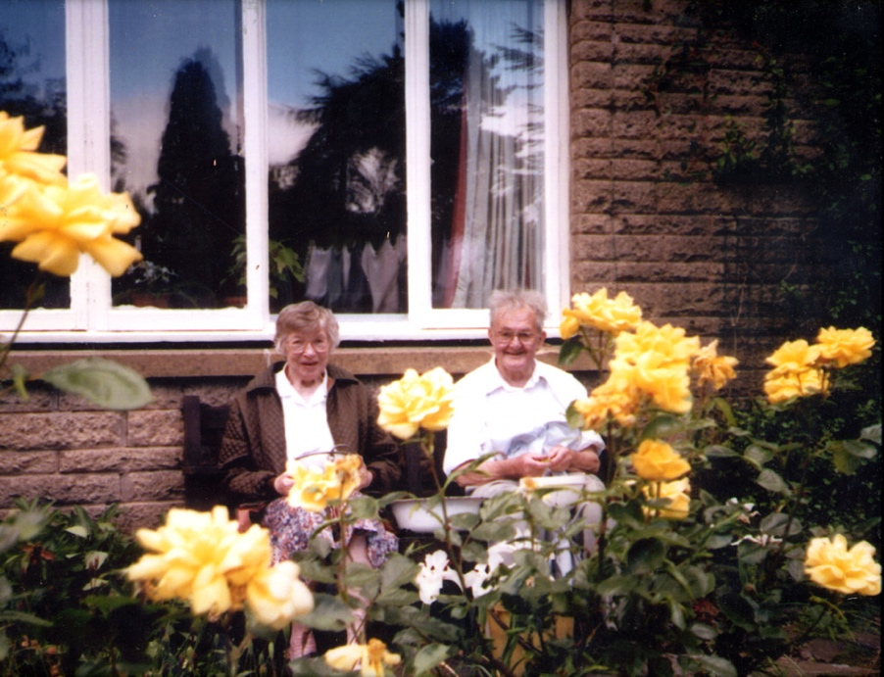
My parents in their beloved garden behind no. 20, Blackbrook Road, Lodge Moor, Sheffield, early 1990s

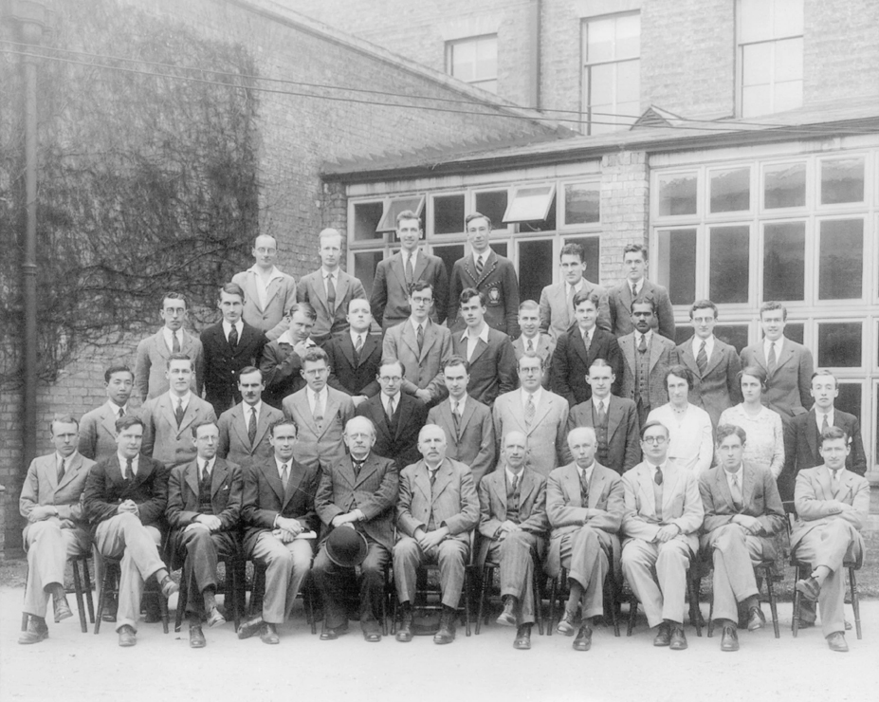
Cavendish Physics Laboratory, Cambridge, 1932
My father, at age 23, is on the far right on the back row.

